
Searching Services
CLIENT
User Guide

Contents
HOME PAGE 5
General User Tips ALL 7
Property Ownership 9
Title Search NSW 10
Returned Title Certificate Options NSW 11
Owner Name Search NSW 12
Selecting Results from Owner Name Search NSW 13
Finding a ‘share ownership’ called a Sub Folio Search NSW 14
Search By Address NSW 15
Reverse Street Address NSW 15
Reverse Proprietor NSW 16
Double Ordering Warning Notice NSW 16
Authenticating Title document NSW 17
This search is used to check the authenticity of a copy of a Title provided by a client 17
17
Viewing Order Results NSW 18
Address Look up from Title Number NSW 19
Lease Searches NSW 20
Finding a Shopping Center Lease 21
Entering Lease Search Information NSW 21
Selecting Lease Documents NSW 22
Property Certificates NSW 23
Property Reports NSW 24
Title Search VIC 25
LAND TITLES VIC 26
Returned Title Certificate Options VIC 27
Selecting Results from Owner Name Search vic 29
Search By Address VIC 30
Finding a ‘share ownership’ called a Folio Index Search VIC 31
Free address search using Vol/ Folio number (i.e. Title) VIC 32
Property Enquiries VIC 33
Verifying Title Authenticity VIC 34
Titles Search QLD 35
Street Address Search QLD 36
Other Searches QLD 37
Finding Body Corp Detail QLD 38
Property Enquiries QLD 39
Selecting Council Certificates QLD 40
Selecting Land Tax Certificates QLD 41
Title Search ACT 42
Ordering Property Enquiries ACT 43
Title Search WA 44
Selecting Title Searches for Other States, SA, NT,TA 45
Title Search South Australia 46
Title Search Northern Territory 47
Land Title Tasmania 48
Company Searches ASIC 49
Company Search Results ASIC 51
Director Name Search ASIC 52
Incorporated Business Name Search 54
Documents ASIC 56
Documents Professionals, Banned & Disqualified ASIC 57
Looking Up Registrations PPSR 58
Individual Search PPSR 59
PPSR Selecting Certificates 60
PPSR Tab Selection 61
Registering PPSR 62
Managing Access Codes PPSR 64
Creating a Registration PPSR 65
Amending a Registration PPSR 66
AFSA Bankruptcy Search 67
AFSA Ordering Extract 68
Person Locator Search 69
Person Locator Search Printing 71
Records Management-Finding past Orders 72
One Touch Fee Summaries 73
Reports 74
Reports by Date Ordered By Person or All 75

HOME PAGE
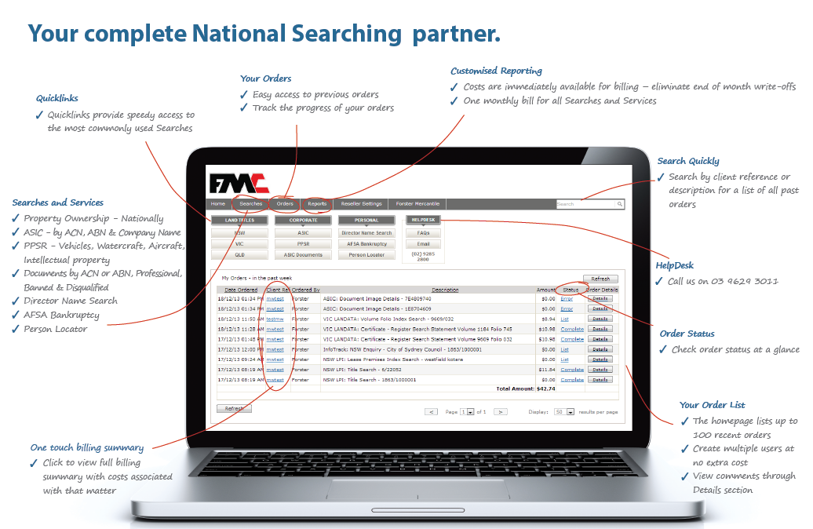

General User Tips ALL
Two ways to find what you need to search for:
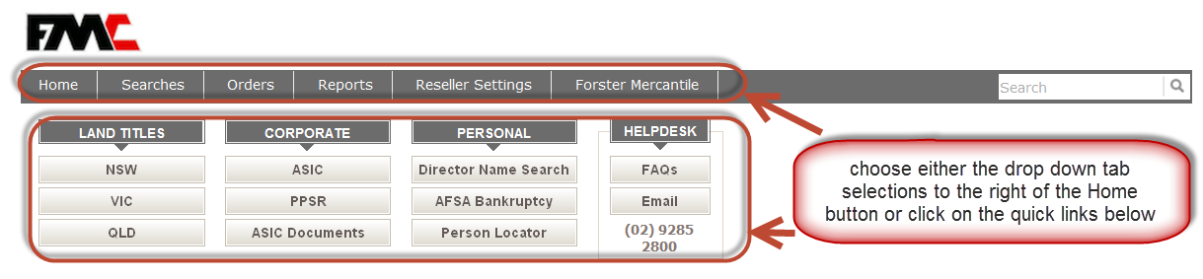

Reference names & numbers identify your searches making it easy to look back and summarise disbursements incurred by a particular matter or client

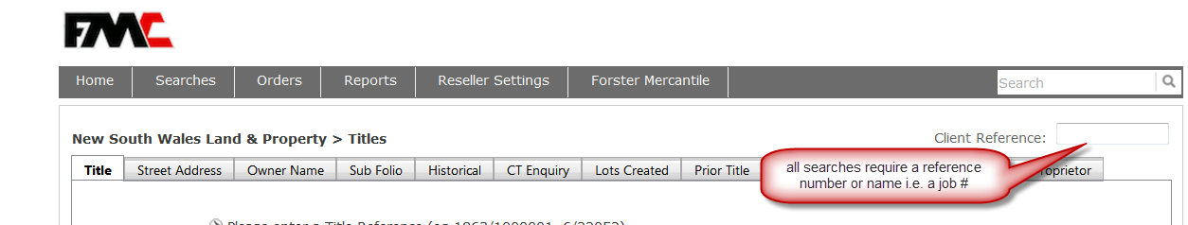

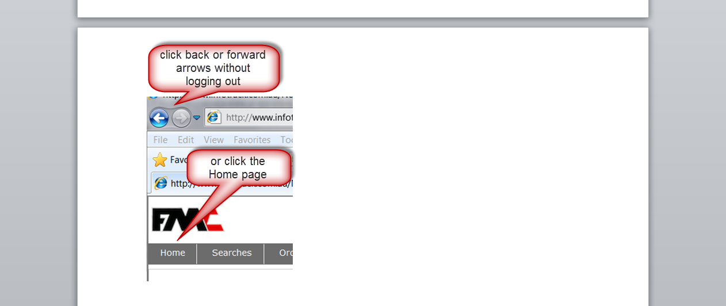
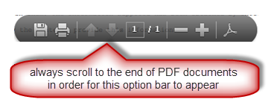

QUICK HINT :You can minimise the Forster Mercantile Searching page to use as required during the day as you will only be logged out automatically at 1.30 am for security purposes

Property Ownership

Find out who owns a property, how many properties an individual owns. Find Owner Names, and Street Address.
Records in each State are maintained by separate authorities with each approaching the storage & retrieval of records (Certificates) in different ways. Some States permit access to records that are unavailable in others. Your FMC Searching Service is designed to enable as many searches as you may require, however the method to ordering these will often vary slightly by each States approach

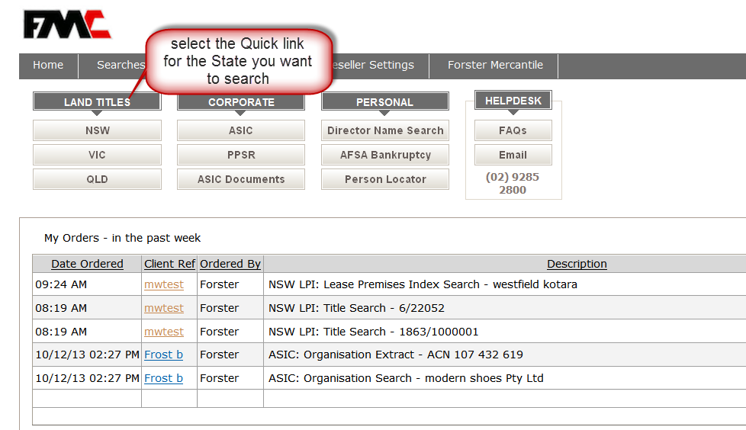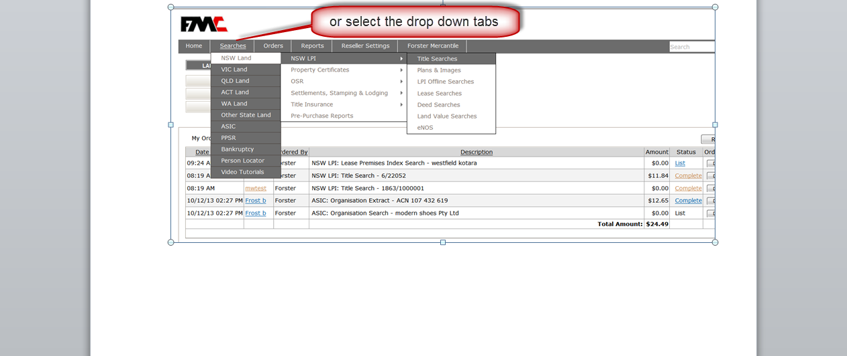

Title Search NSW
The opening page defaults directly to search for information when you already have a Title number
When this is not the case simply select one of the tabs to find the number by other means

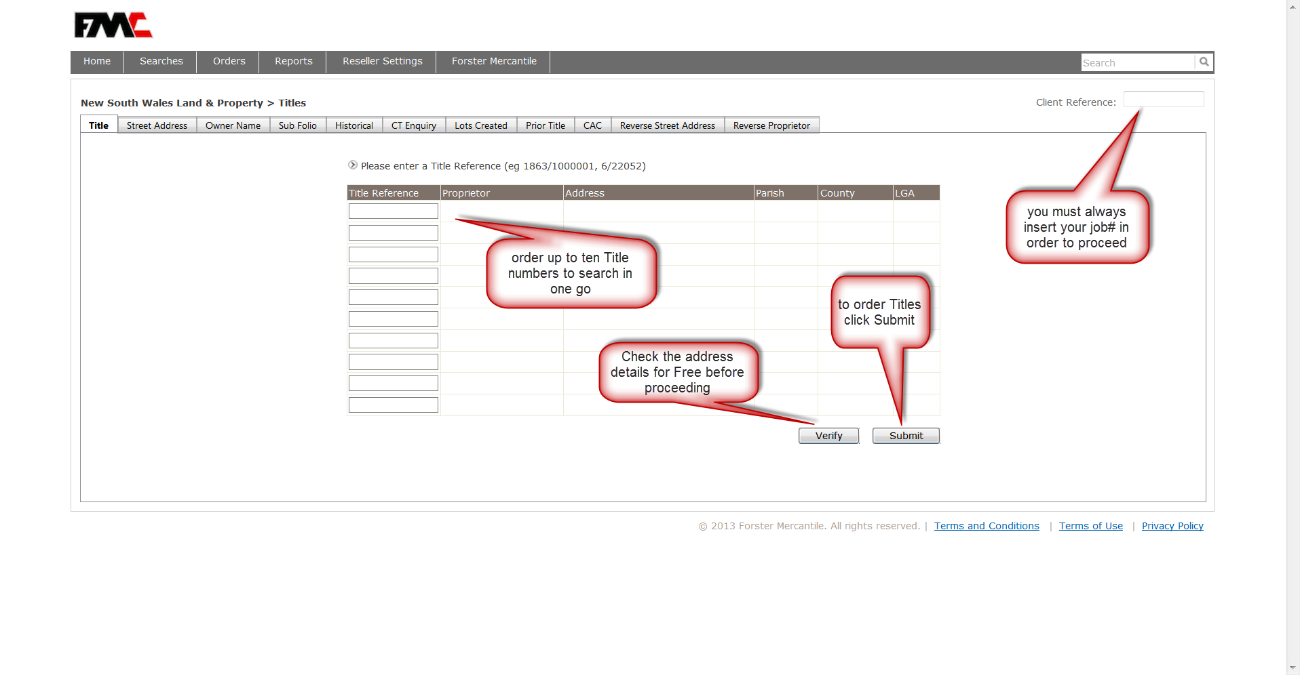

Returned Title Certificate Options NSW

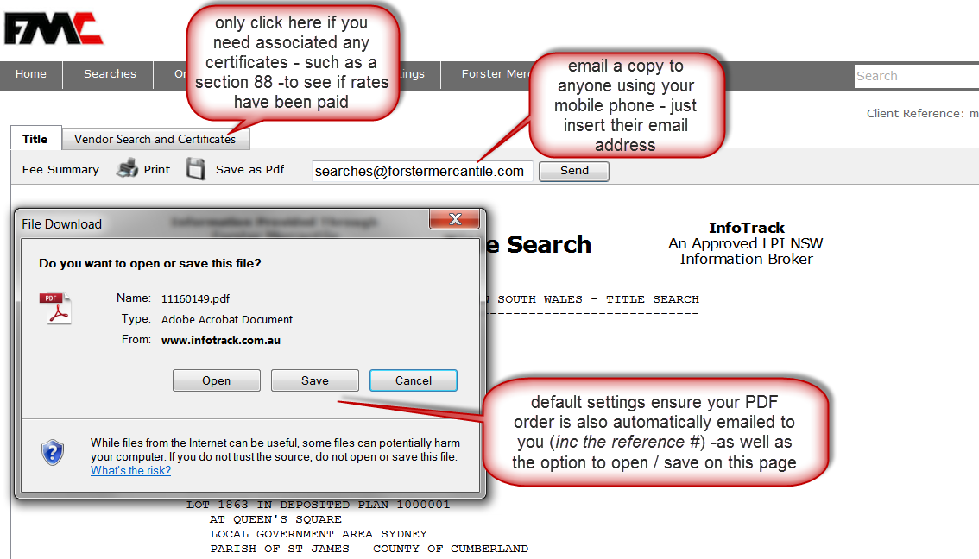

Owner Name Search NSW

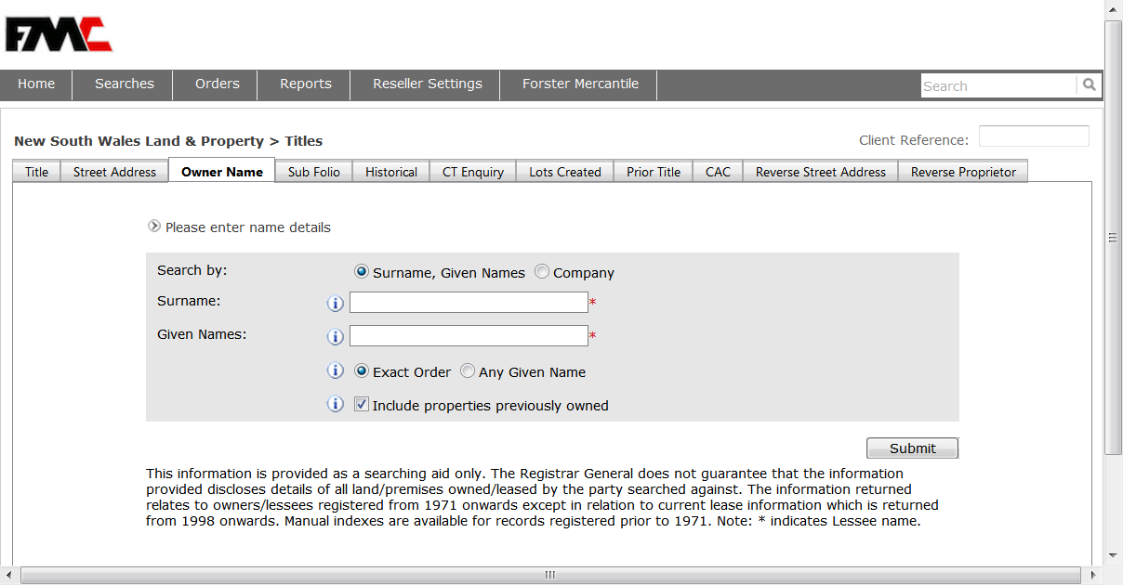

Selecting Results from Owner Name Search NSW
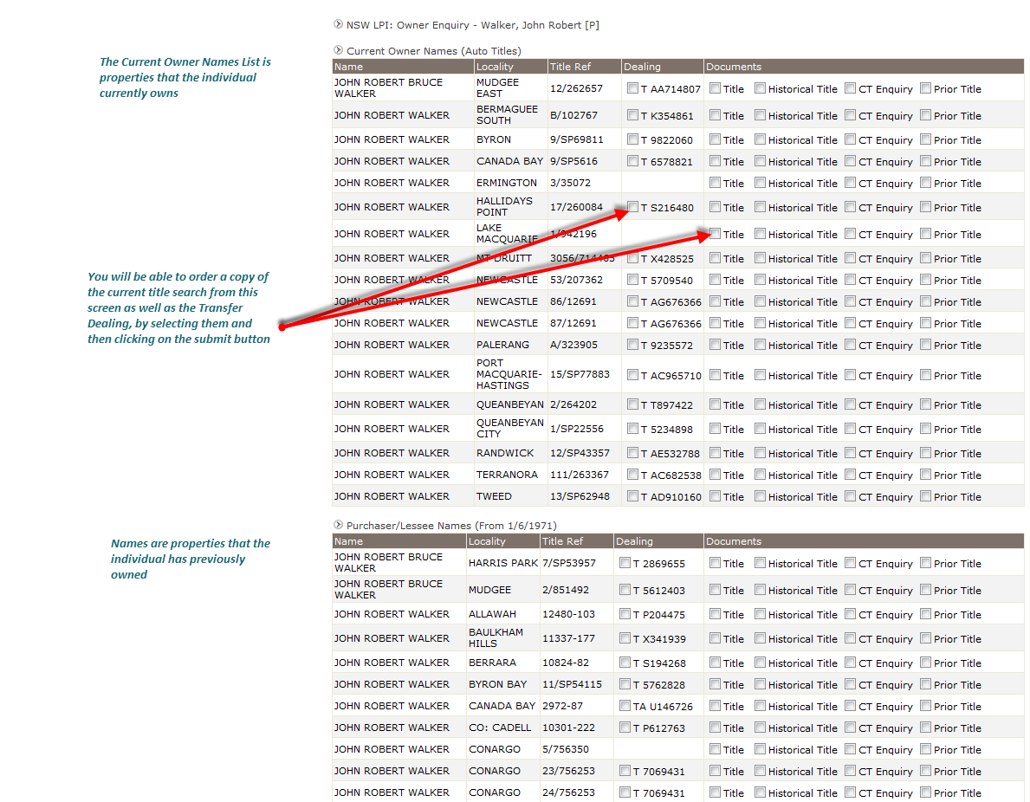

Finding a ‘share ownership’ called a Sub Folio Search NSW

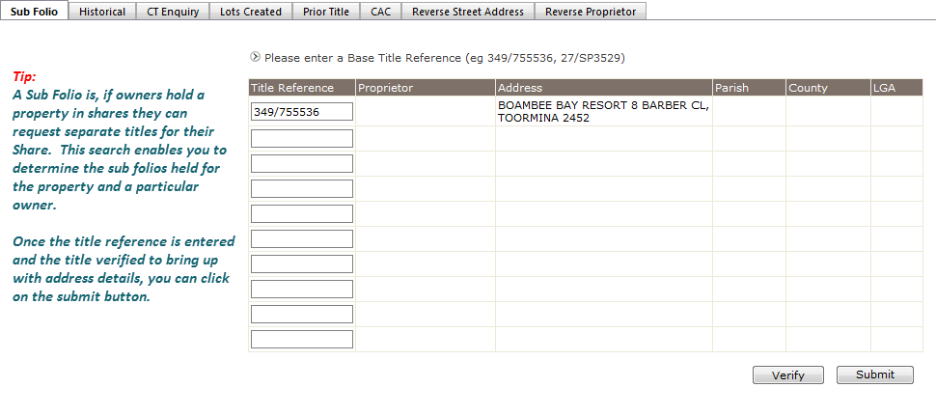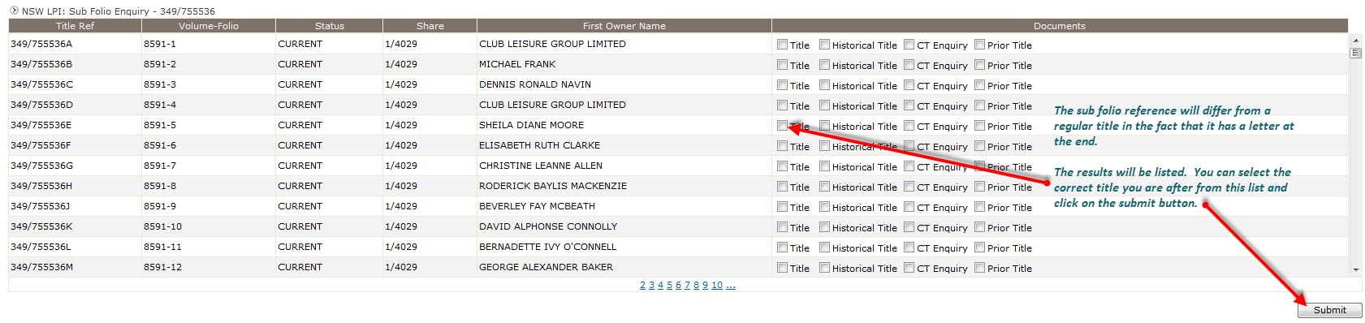

Search By Address NSW
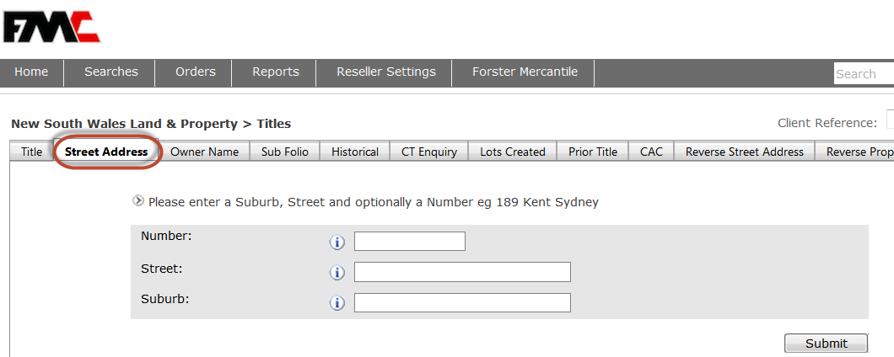

QUICK HINT:These searches will return the Title Number. You then need to do a Title Search

Reverse Street Address NSW
This search along with Reverse Proprietor will return the owners details when all you have is a Title number
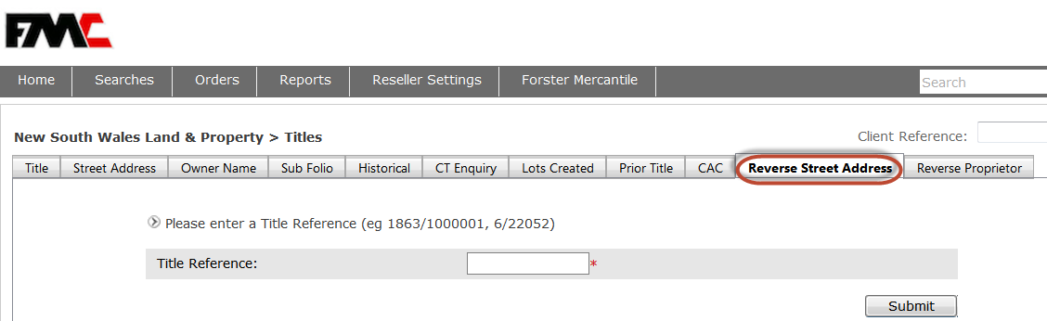

Reverse Proprietor NSW
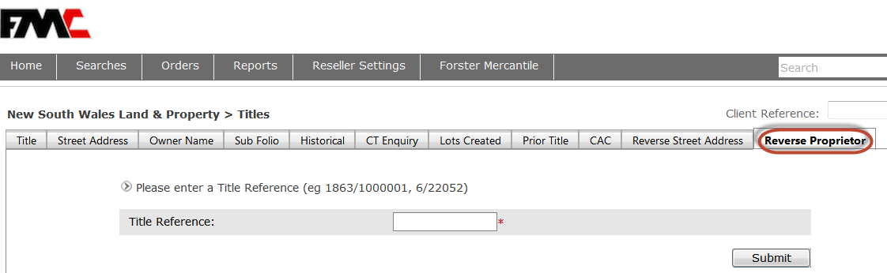
QUICK HINT: To avoid accidental double orderingsimply check on the Home page. You can also click the back arrow and forward arrow without being logged out.

Double Ordering Warning Notice NSW
The warning appears in a 24 hour time frame when the same person orders the same certificate for the same client reference
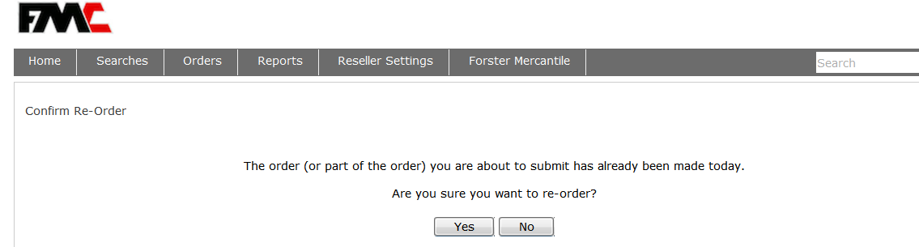

Authenticating Title document NSW

This search is used to check the authenticity of a copy of a Title provided by a client

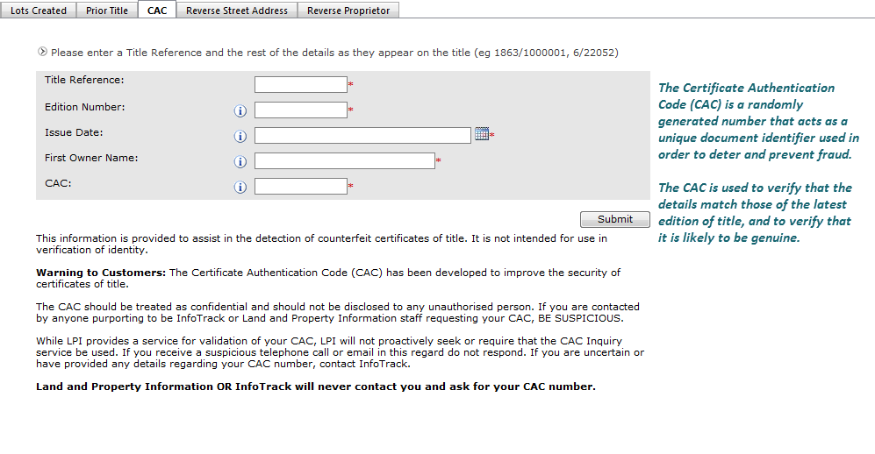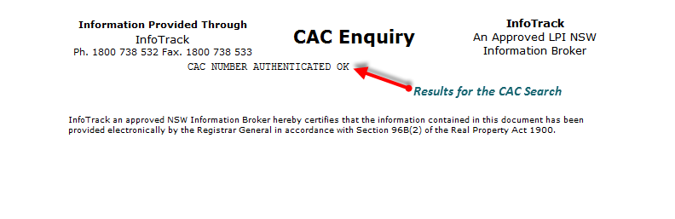

Viewing Order Results NSW

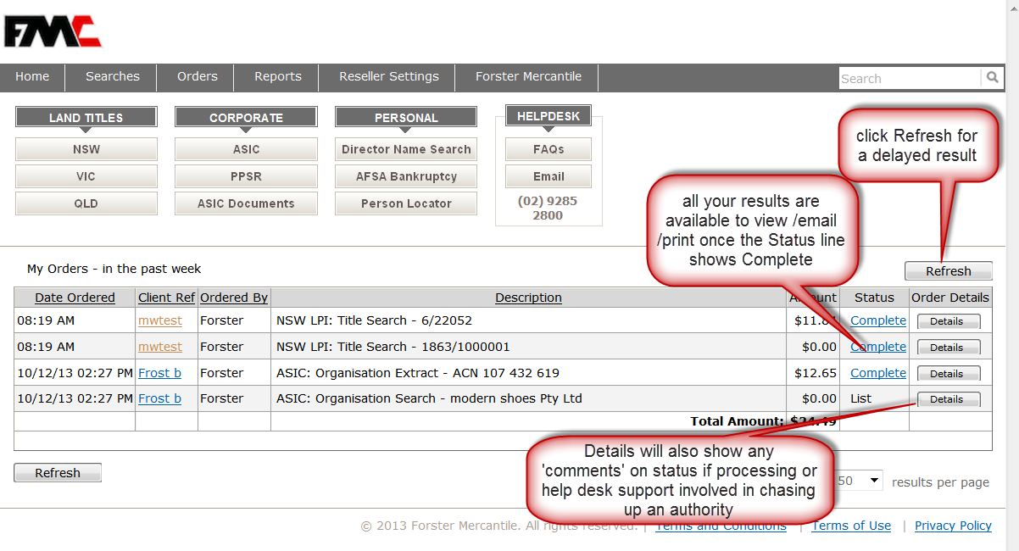

Address Look up from Title Number NSW

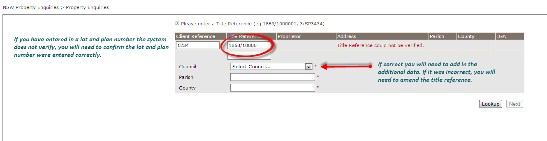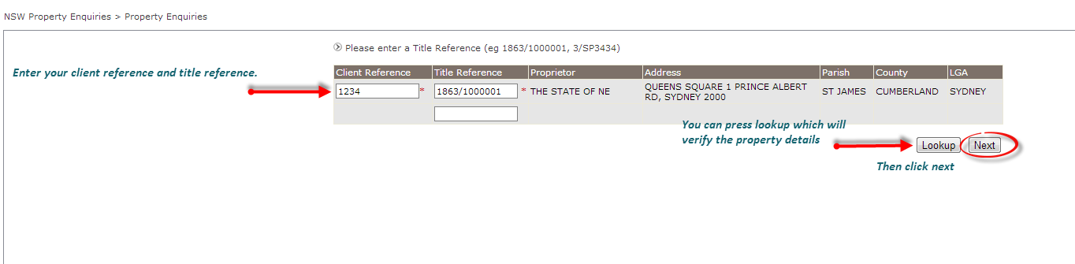

Lease Searches NSW
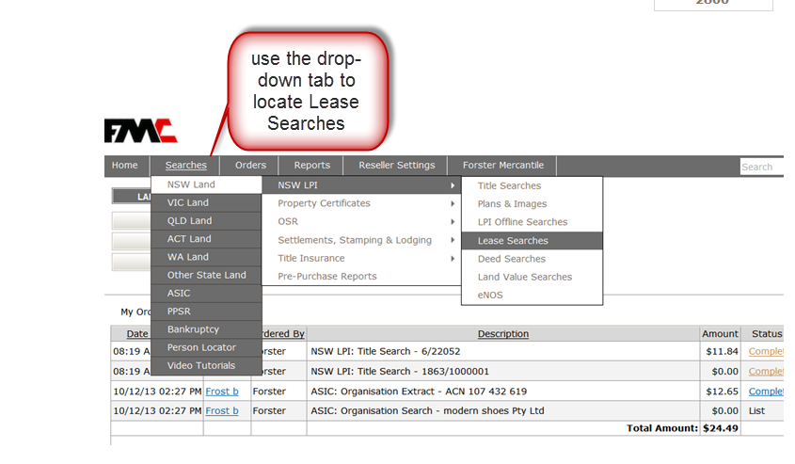

Finding a Shopping Center Lease
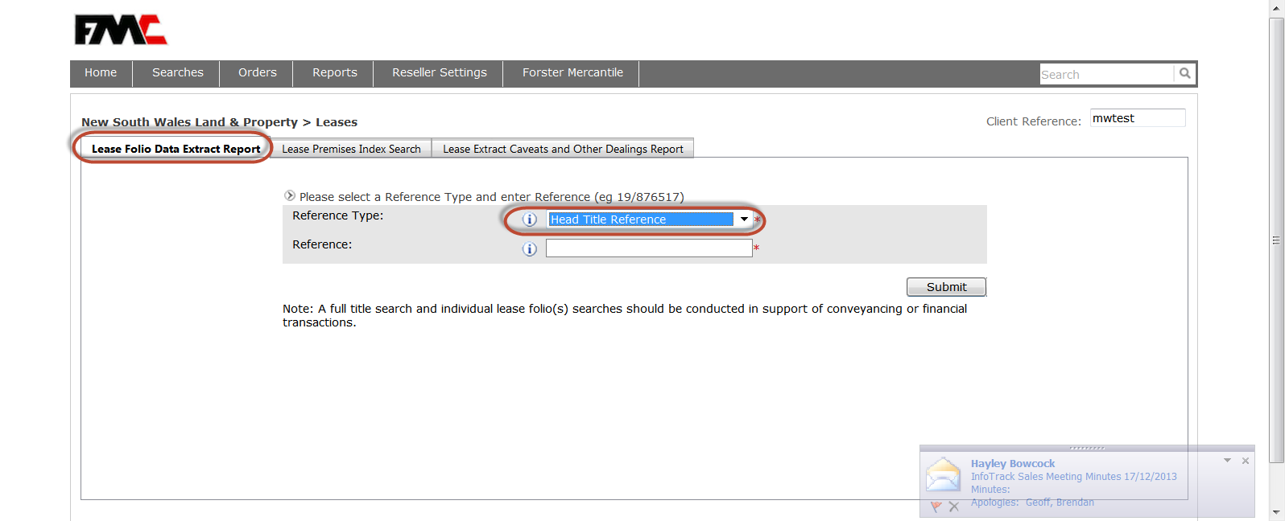

Entering Lease Search Information NSW
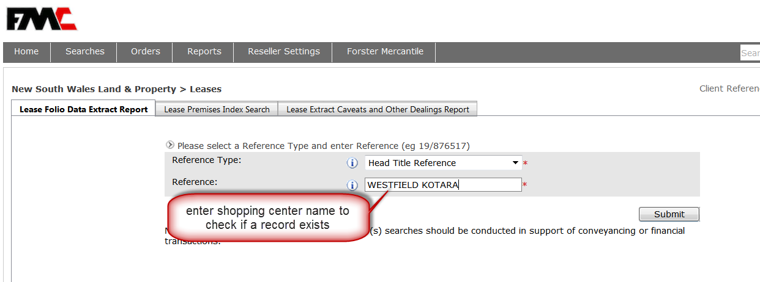

Selecting Lease Search Documents NSW

Selecting Lease Documents NSW
At the present time these Lease searches are only available in NSW
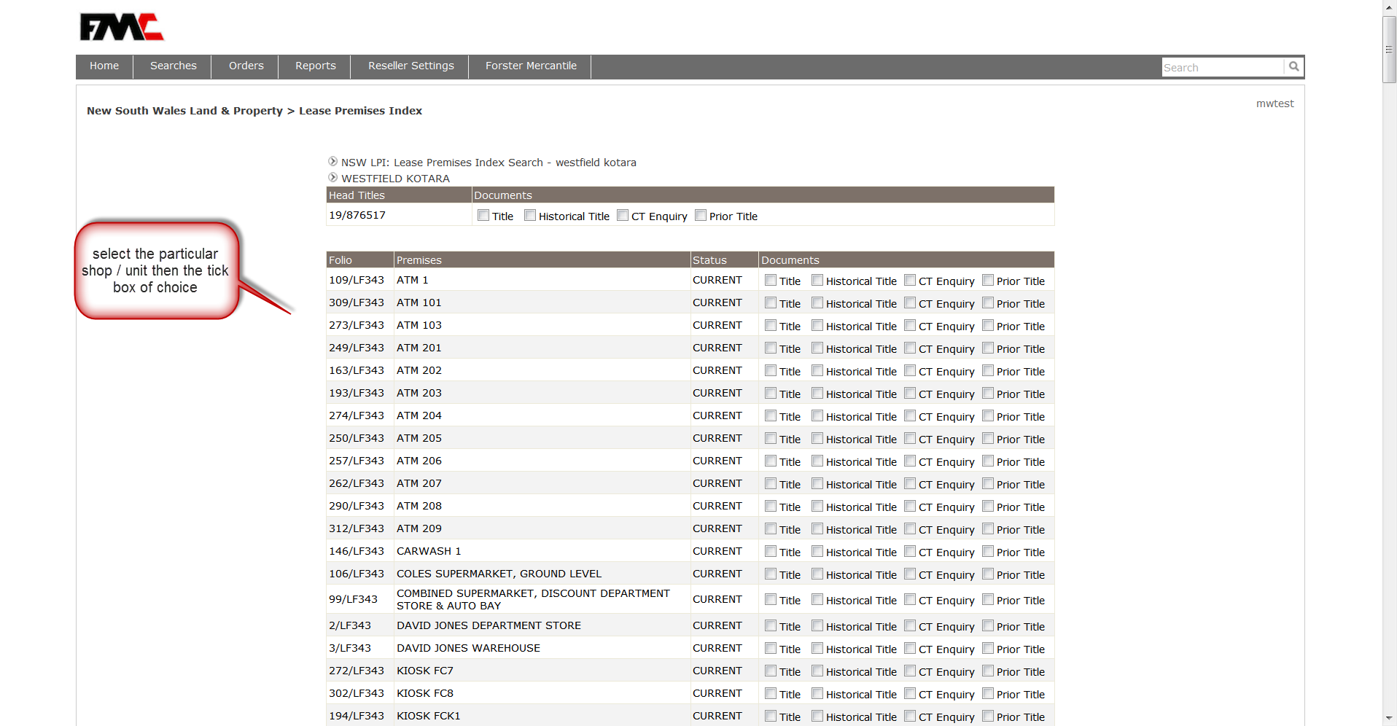

Property Certificates NSW
Check numerous reports on a property such as: if the owner has paid their Rates, if a property is Heritage listed, or has any pending interests over the title by an authority such as rail or road widening, defence, resources & energy, native title, Telco cables or Gas Networks

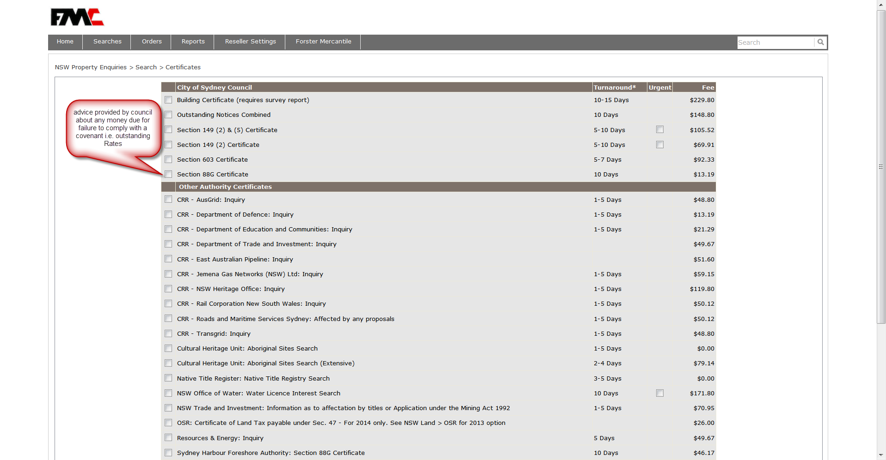

Property Reports NSW
For when you need to consider relevant facts pertaining to a group of shops , apartments in a complex or a group of owners in a Community Title

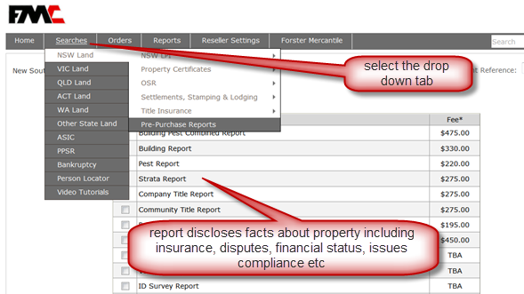

Title Search VIC

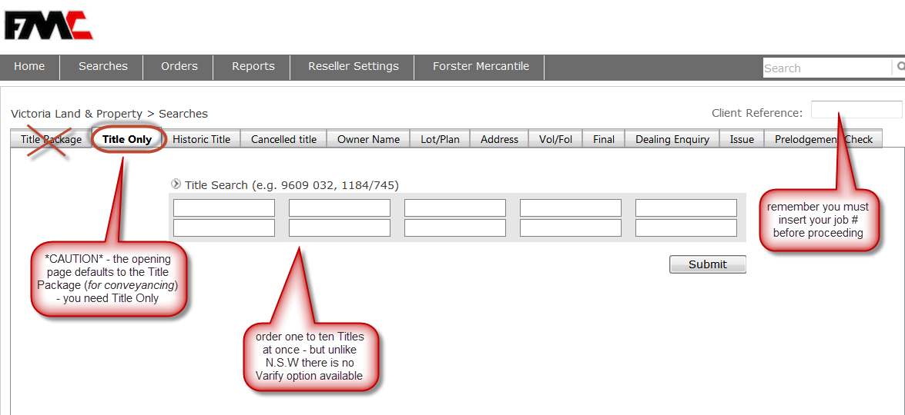

LAND TITLES VIC
Once you have completed the Landata Deed simply select the ‘Title Only’ tab to find the owner of a property
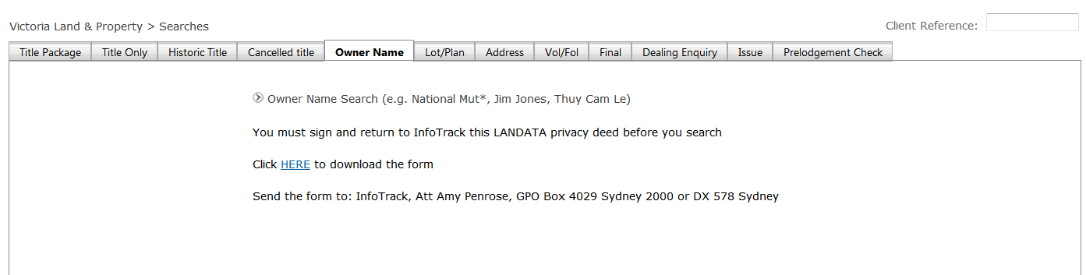

Please Note:
Due to Privacy laws in Victoria clients must first download, complete, sign and then email this form to: michael.witt@infotrack.com.au
Upon receipt you will be notified by email that the account has been activated

Returned Title Certificate Options VIC
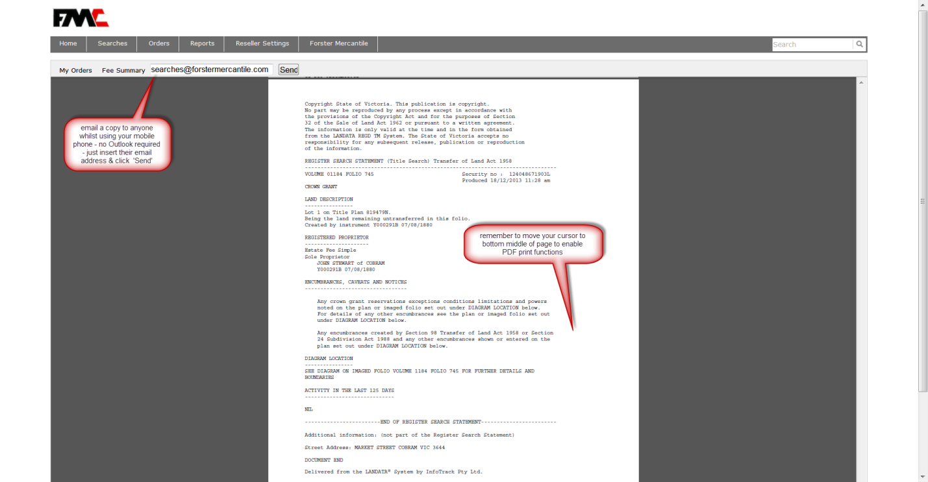

Historic Title VIC
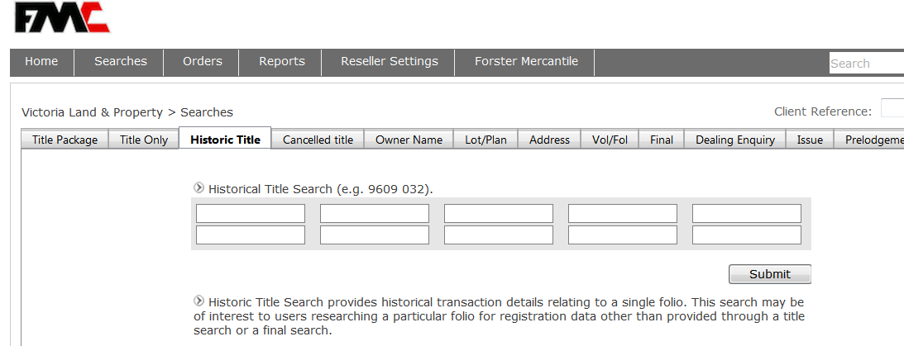
Owner Name Search VIC
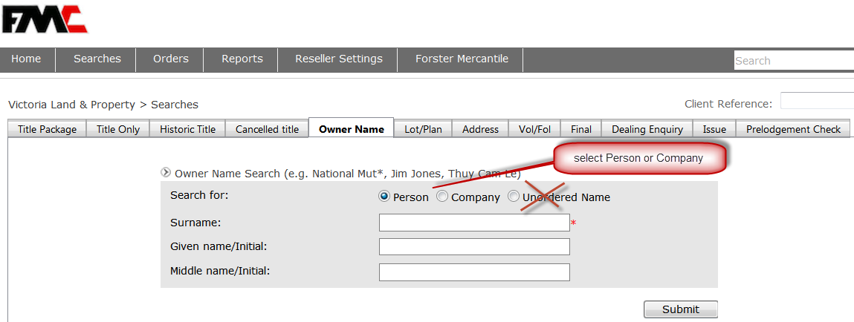

Selecting Results from Owner Name Search vic

Search By Address VIC
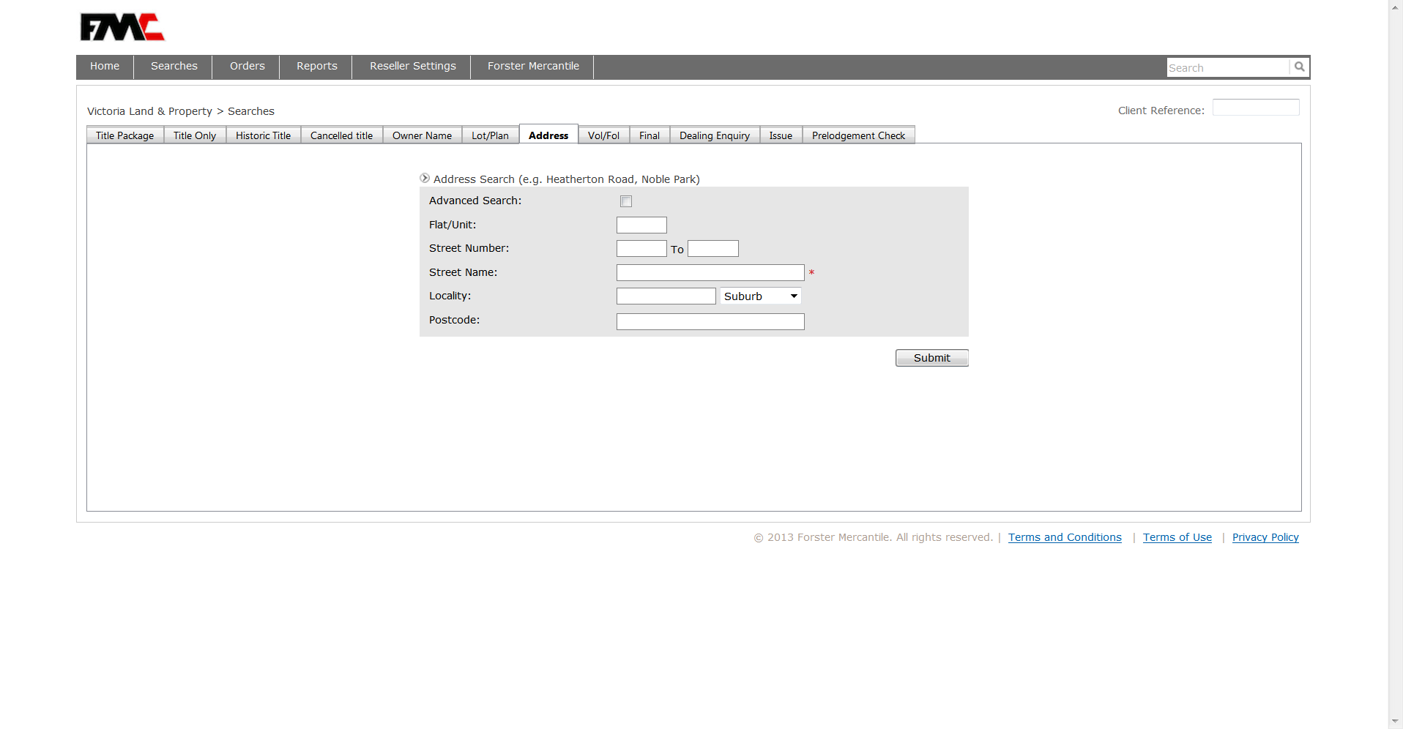

Finding a ‘share ownership’ called a Folio Index Search VIC
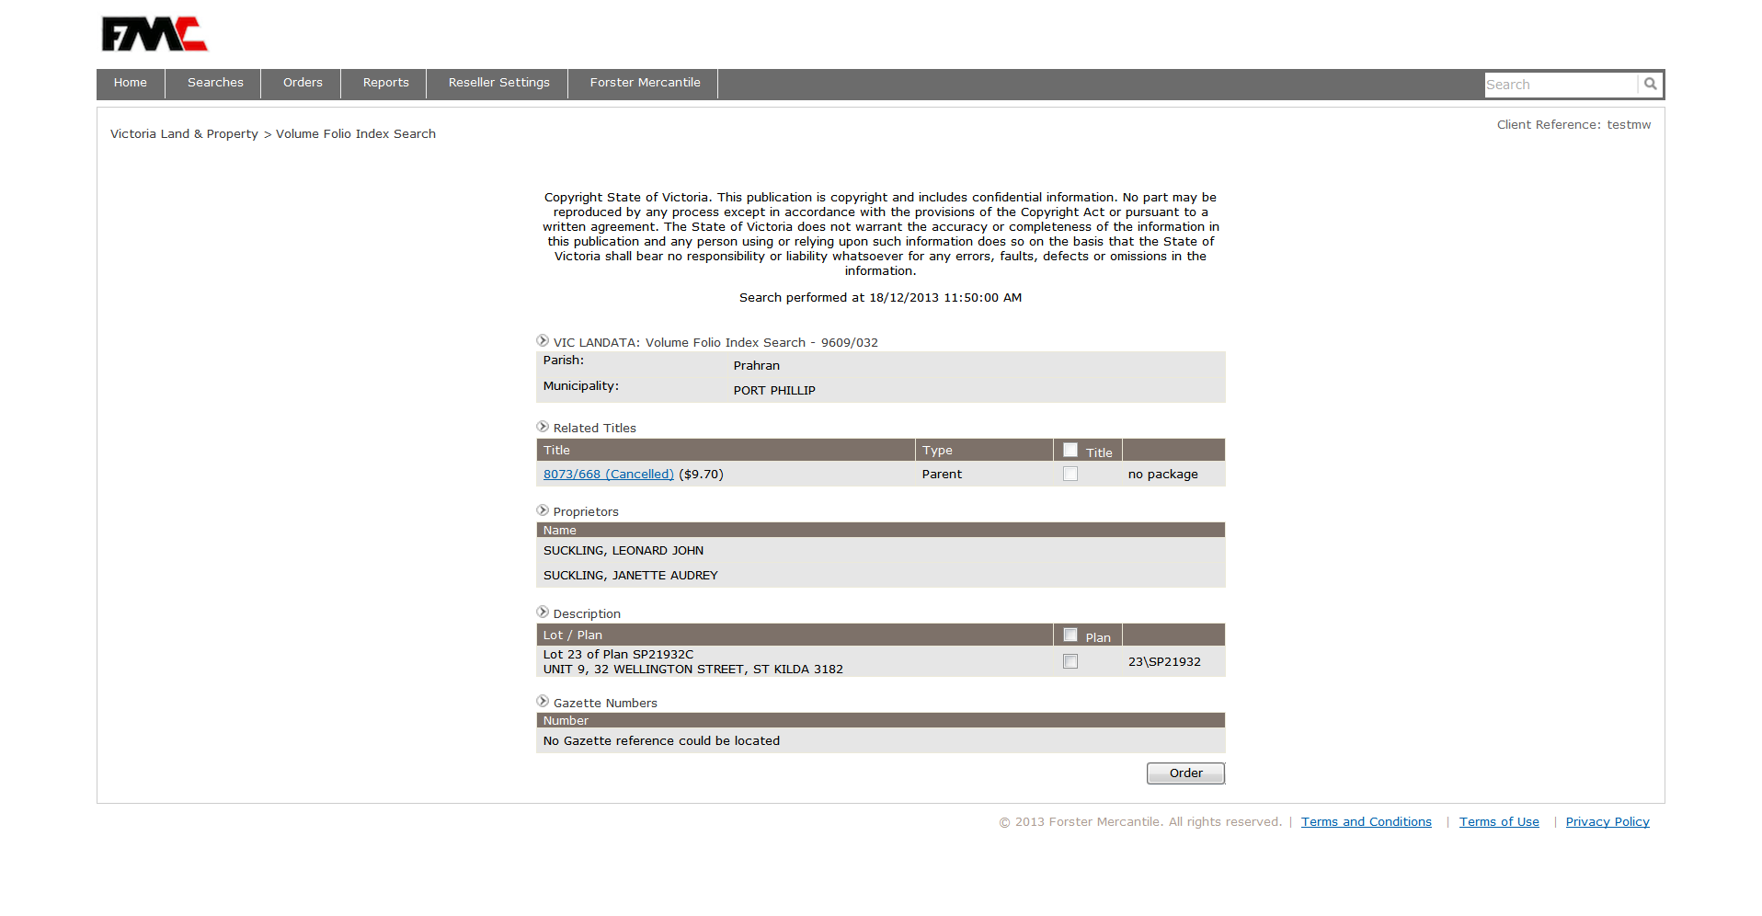

Free address search using Vol/ Folio number (i.e. Title) VIC
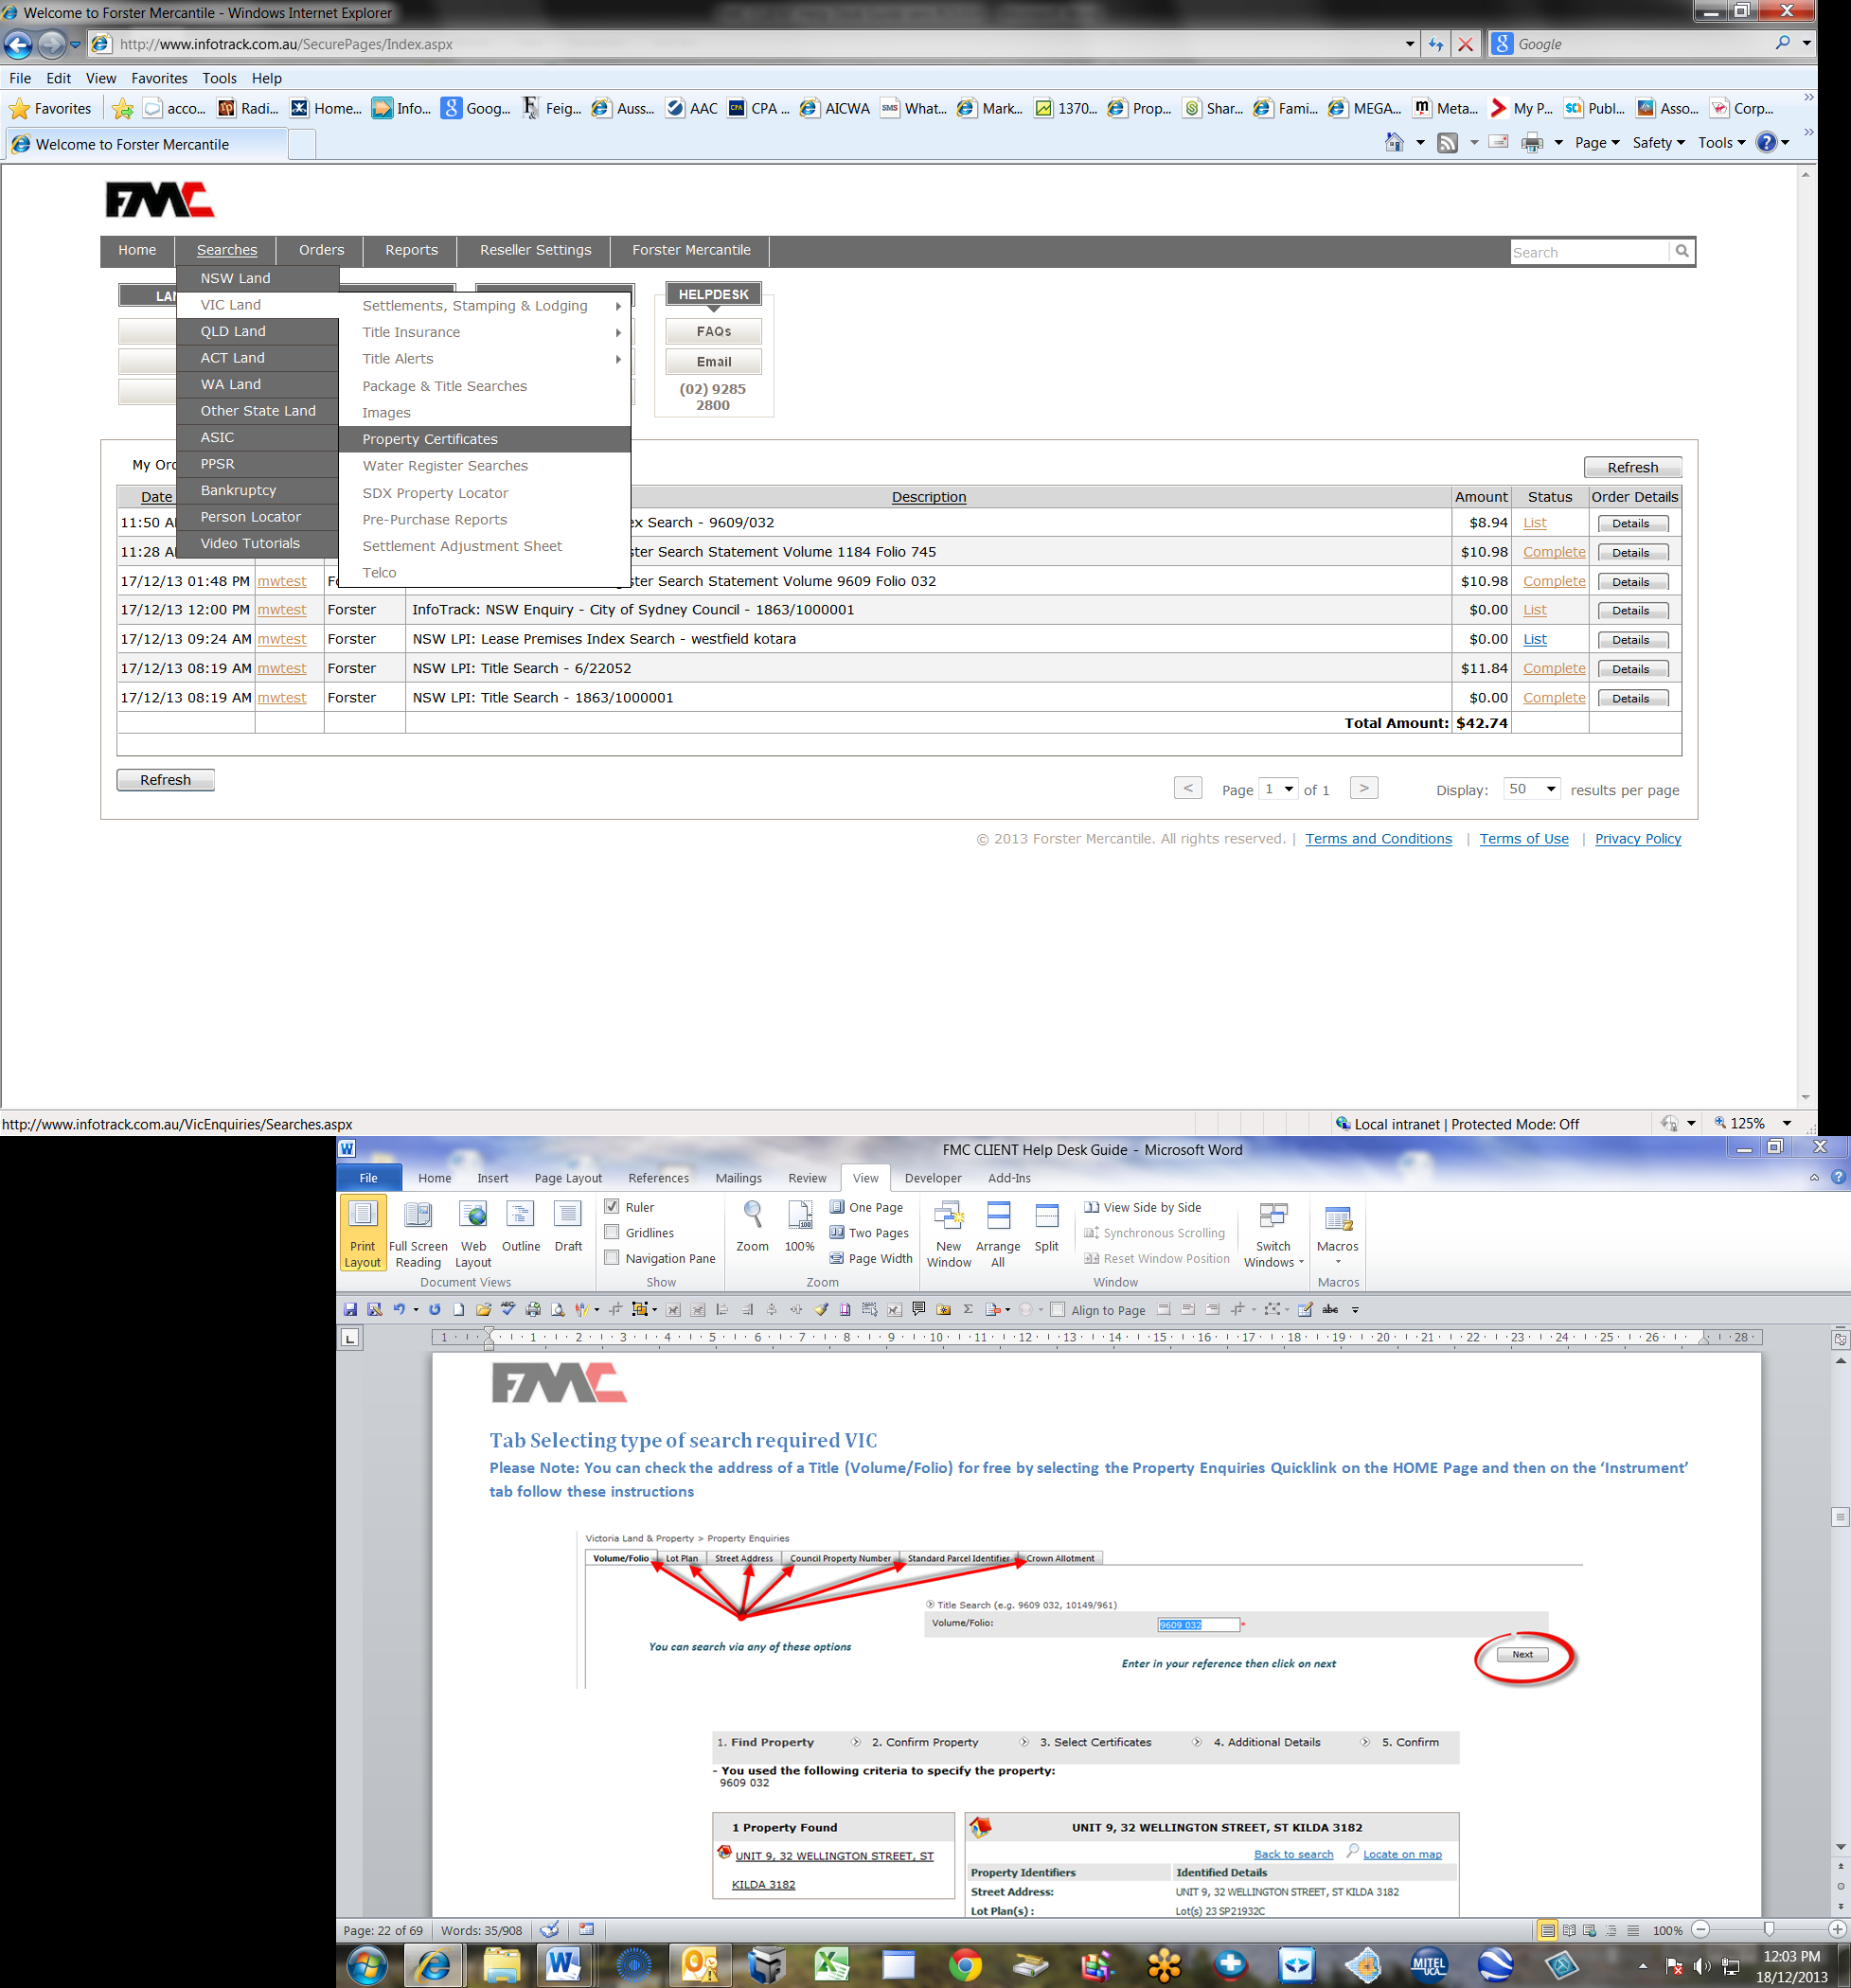
You can check the address of a Title (Volume/Folio) for free by selecting the Property Enquiries Quicklink on the HOME Page and then on the ‘Instrument’ tab follow these instructions

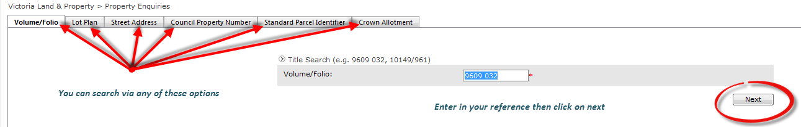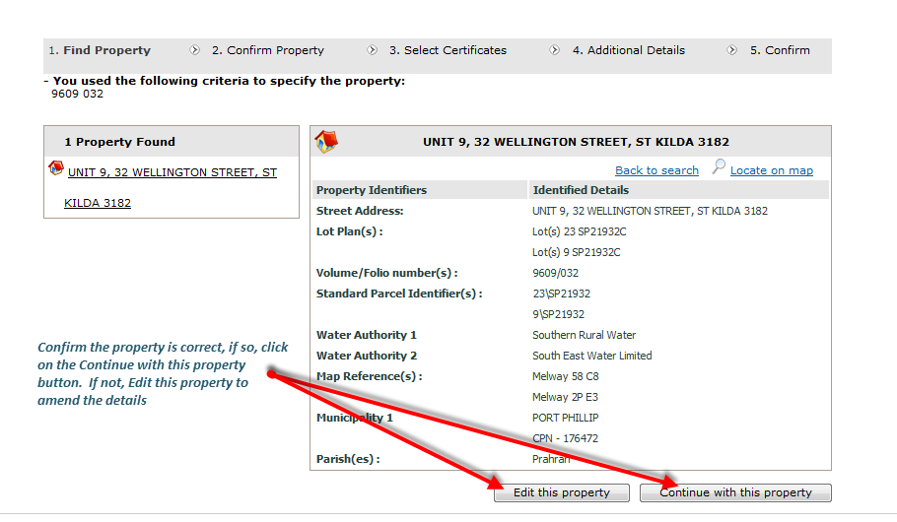

Property Enquiries VIC
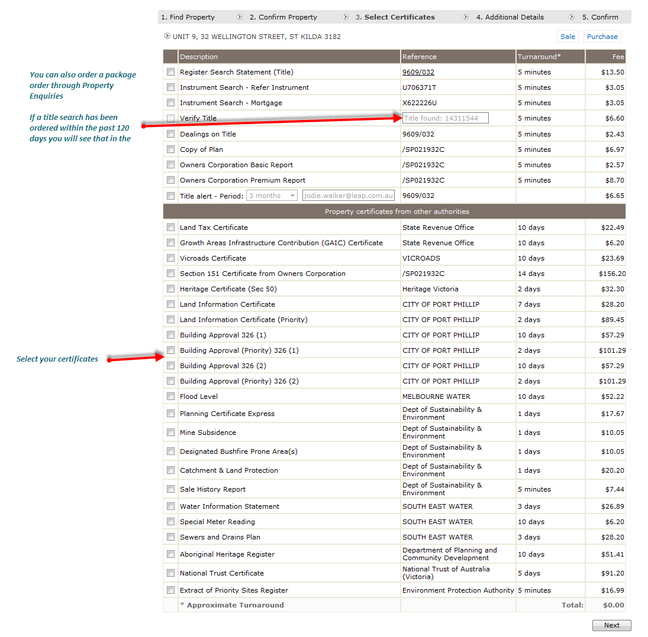
From the previous page you will be presented with the selections of all certificates available for you to select when you click on ‘Continue with this property”

Verifying Title Authenticity VIC
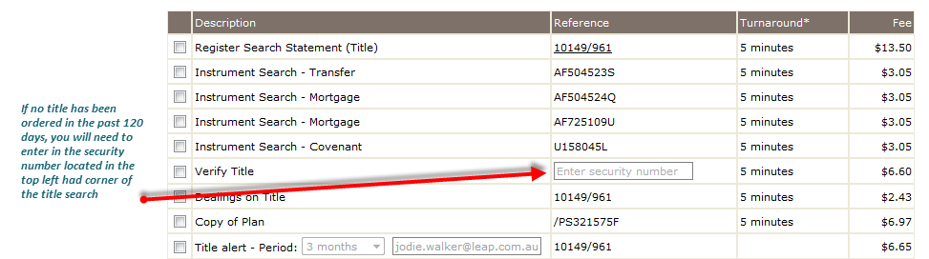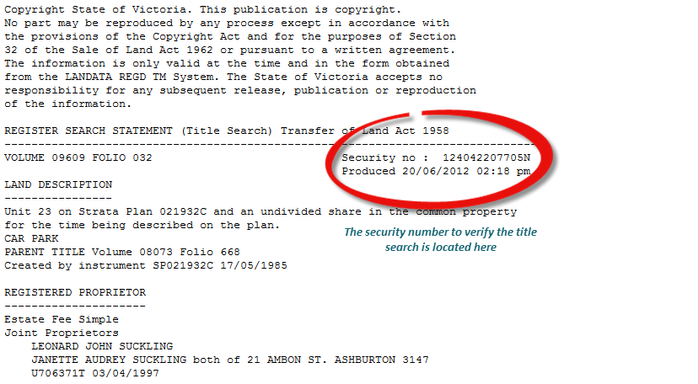

TitlesSearch QLD

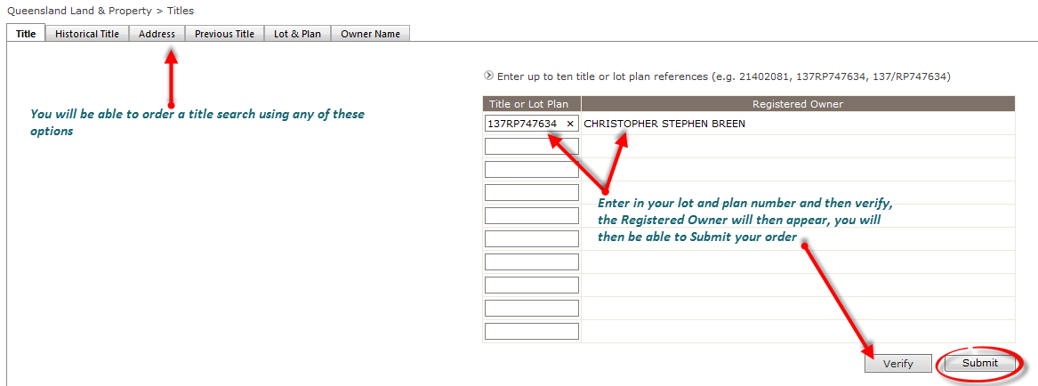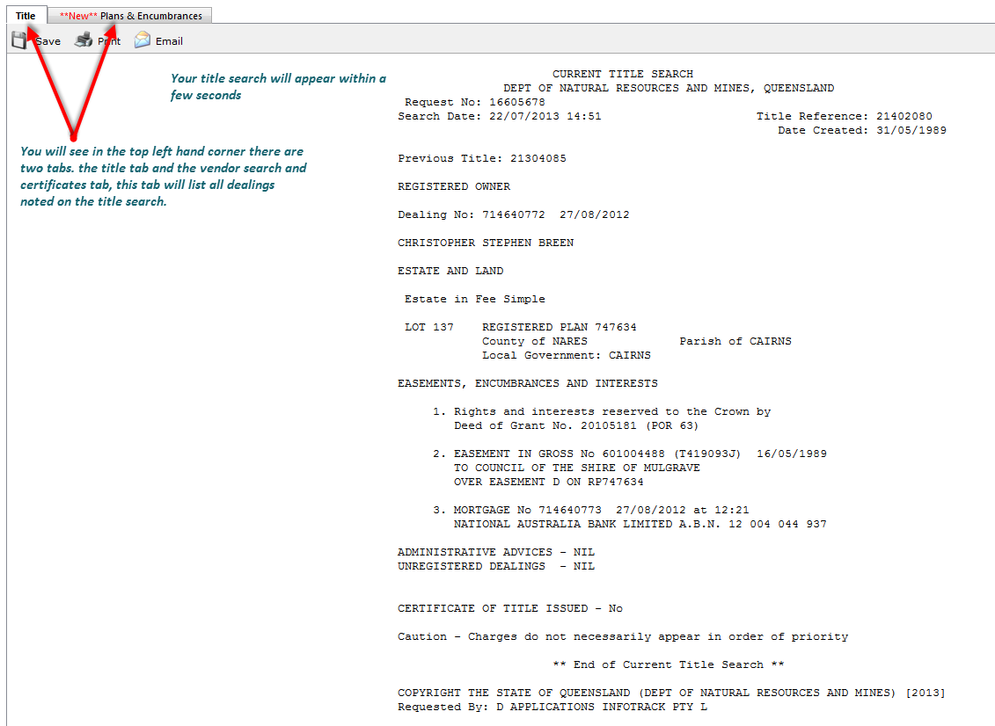

Street Address Search QLD

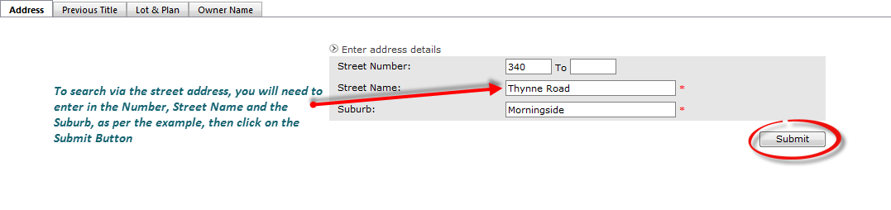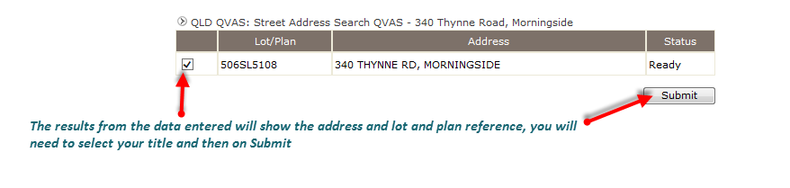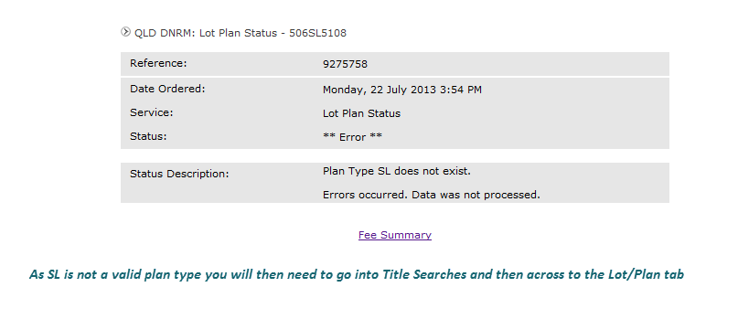

Other Searches QLD

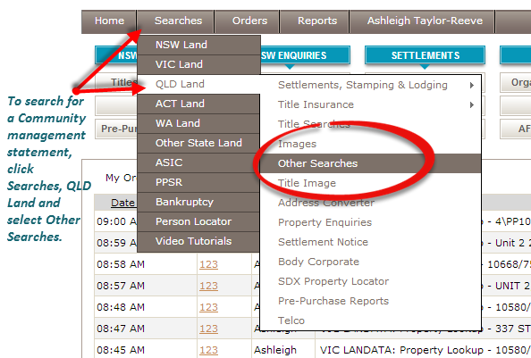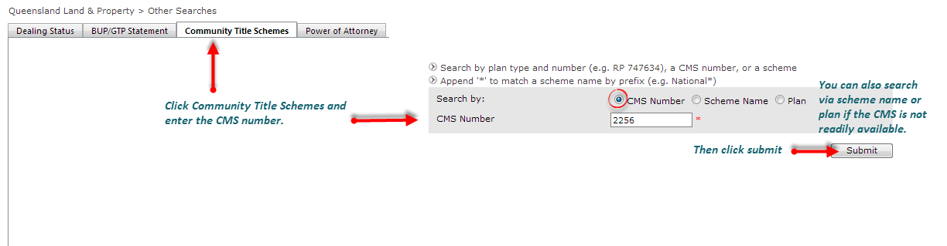

Finding Body Corp Detail QLD
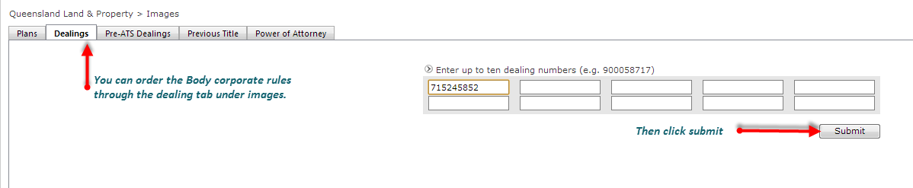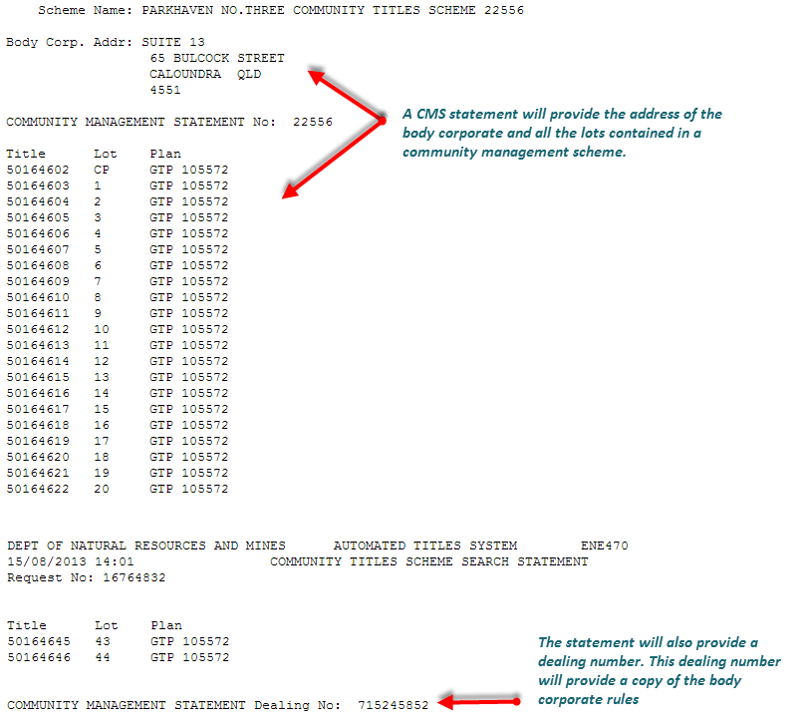

Property Enquiries QLD
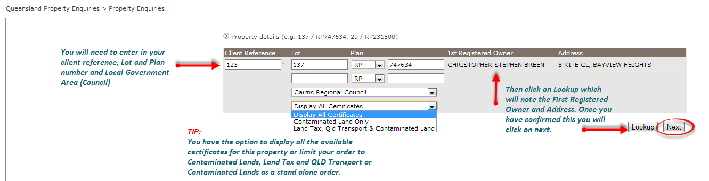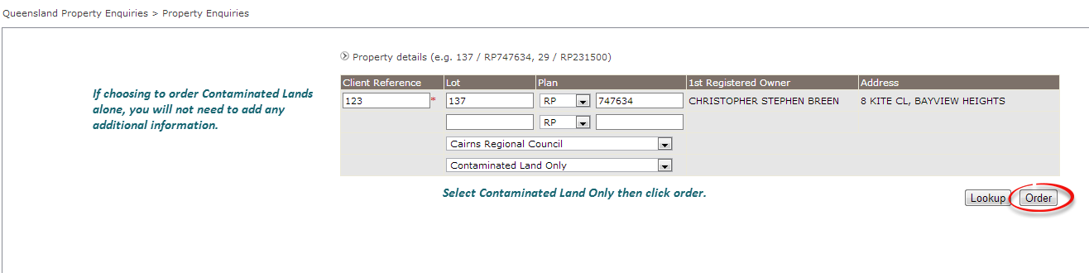

Selecting Council Certificates QLD

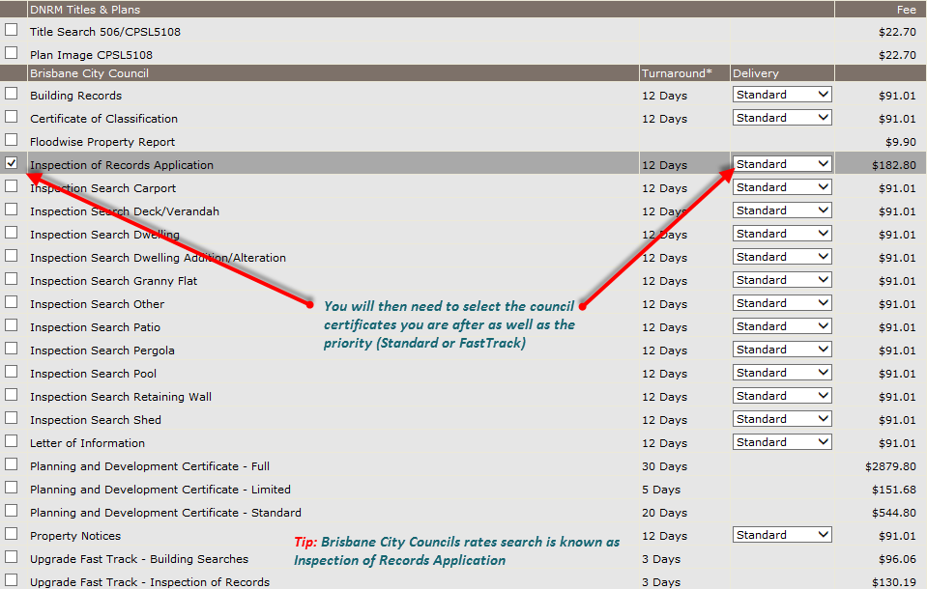

Selecting Land Tax Certificates QLD
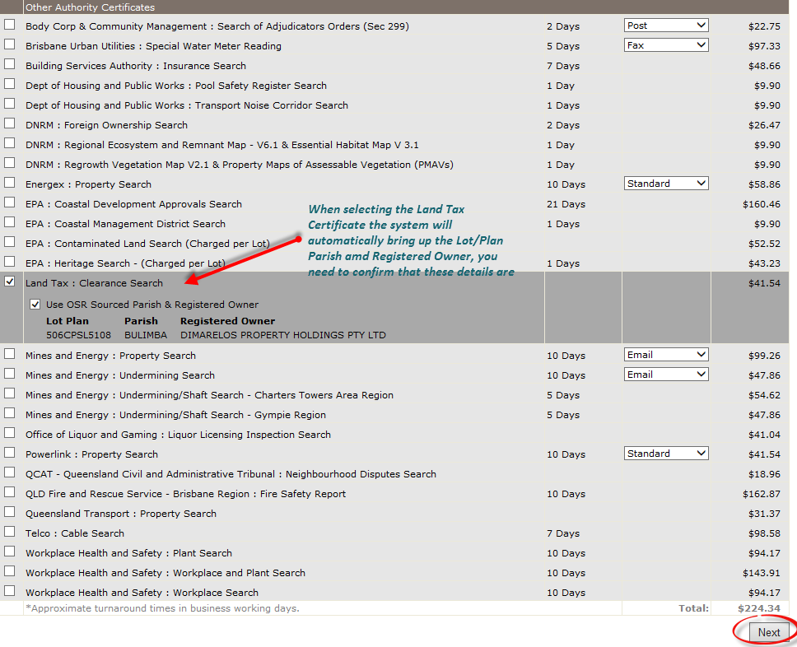

Title Search ACT
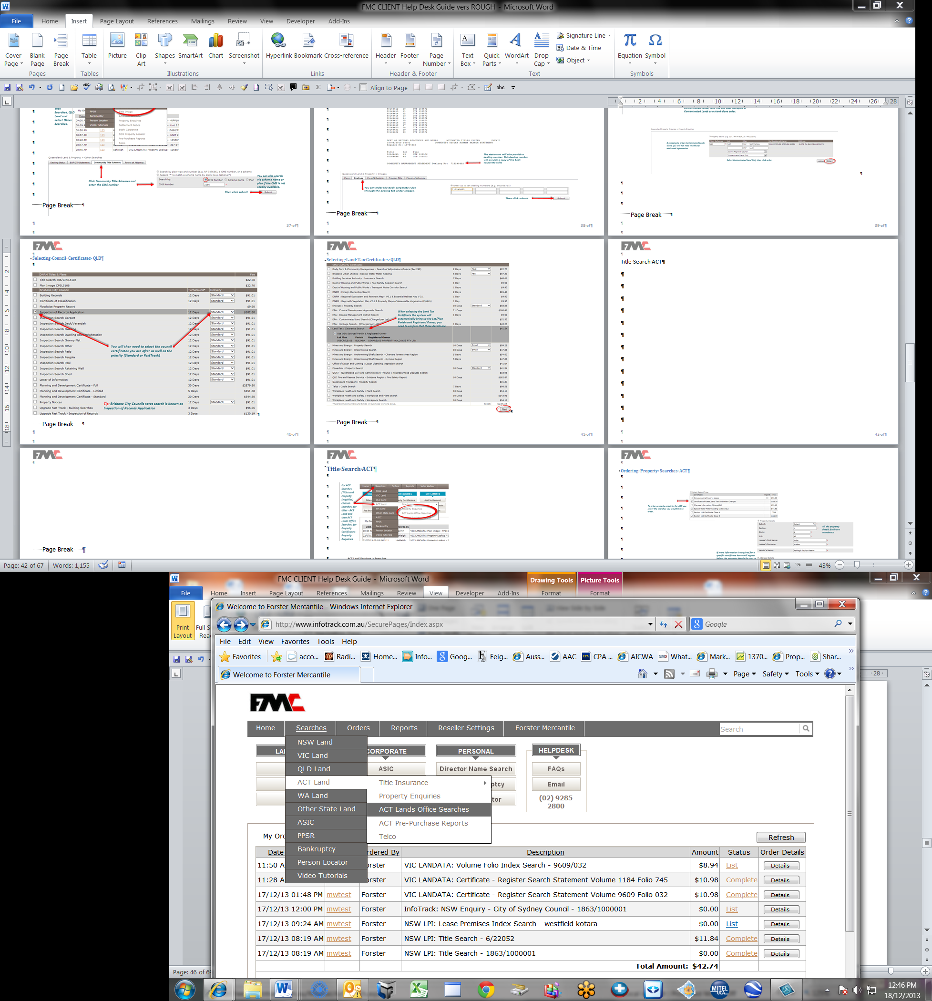
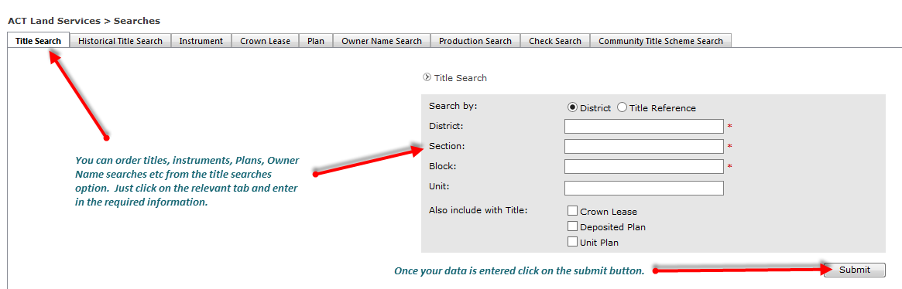

Ordering Property Enquiries ACT
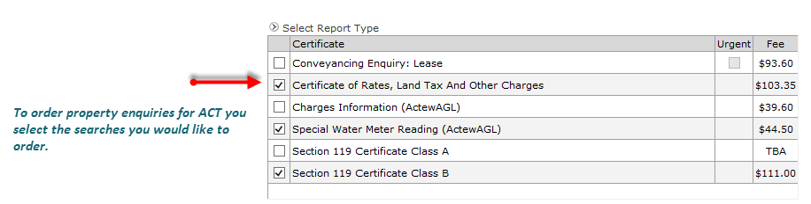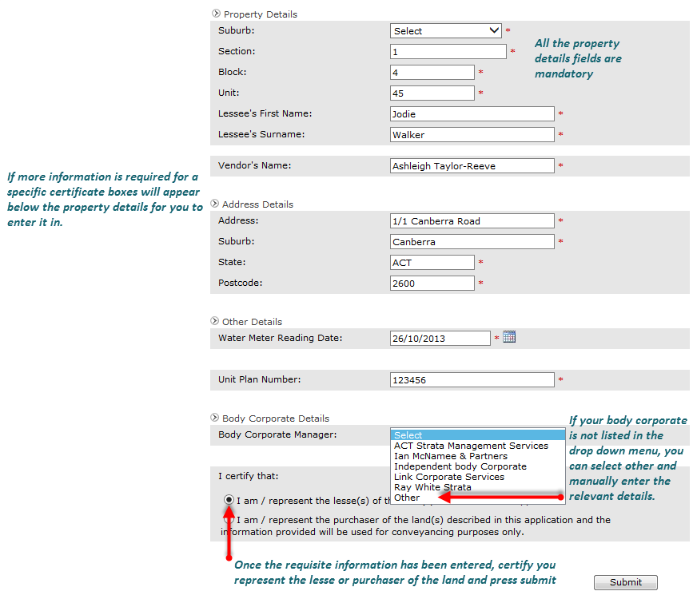

Title Search WA

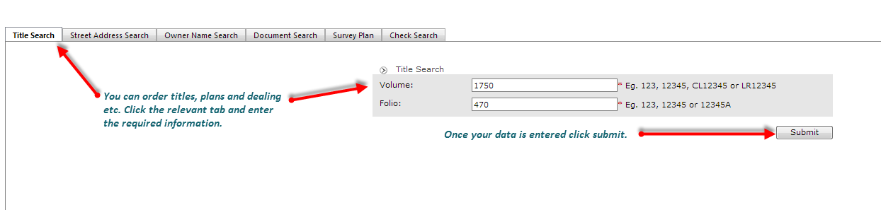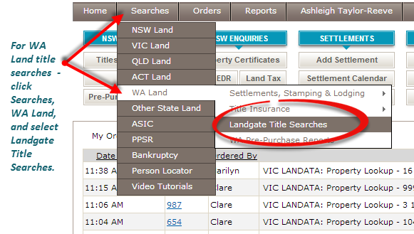

Selecting Title Searches for Other States, SA,NT,TA

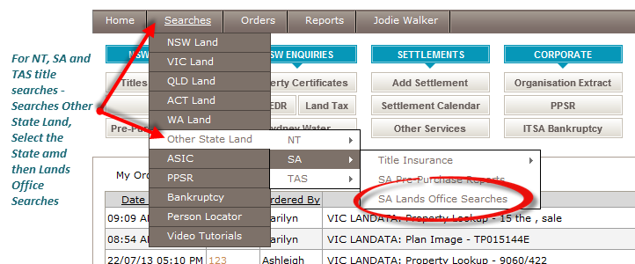

TitleSearch South Australia
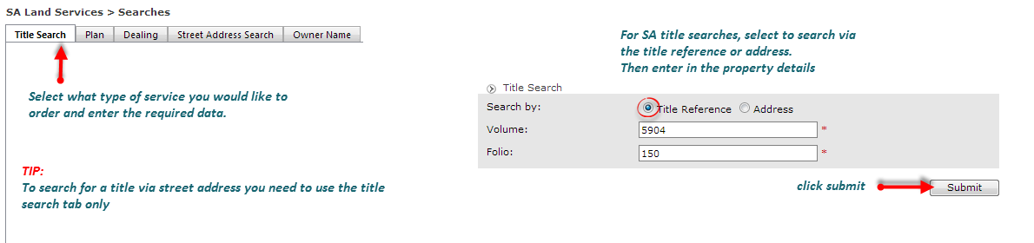

Title Search Northern Territory

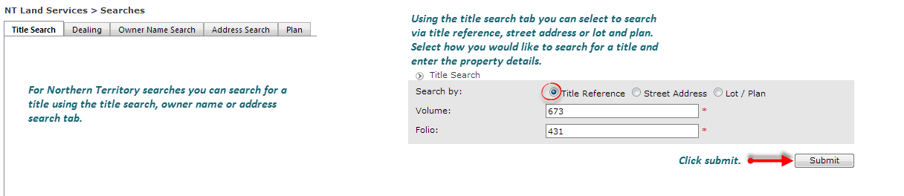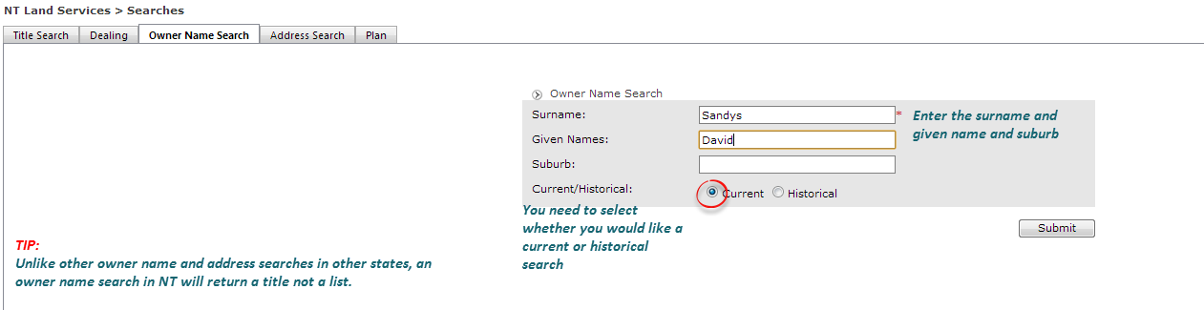

Land Title Tasmania

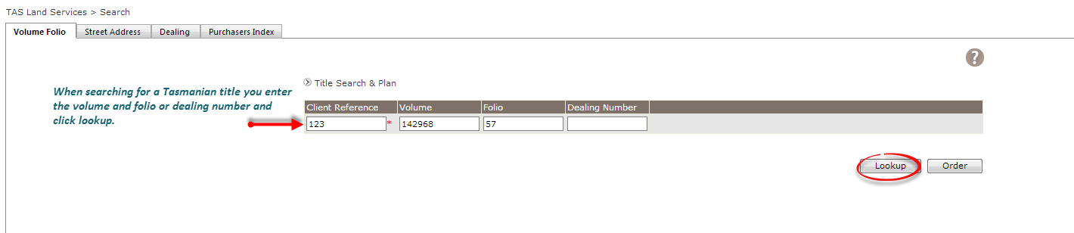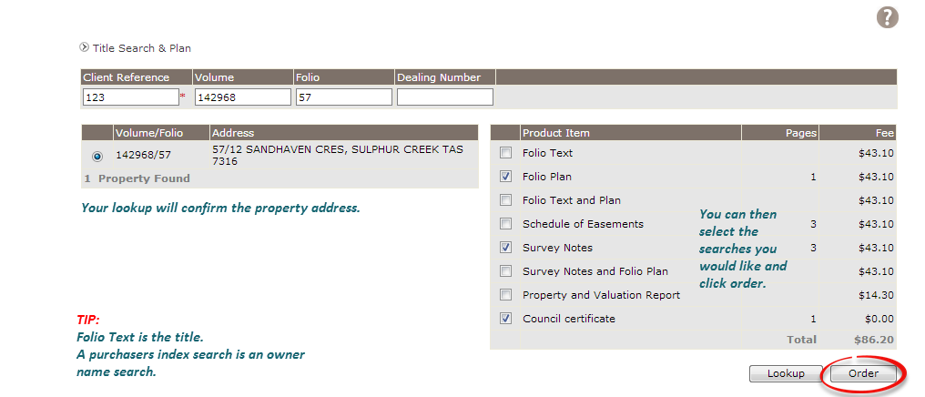

Company SearchesASIC
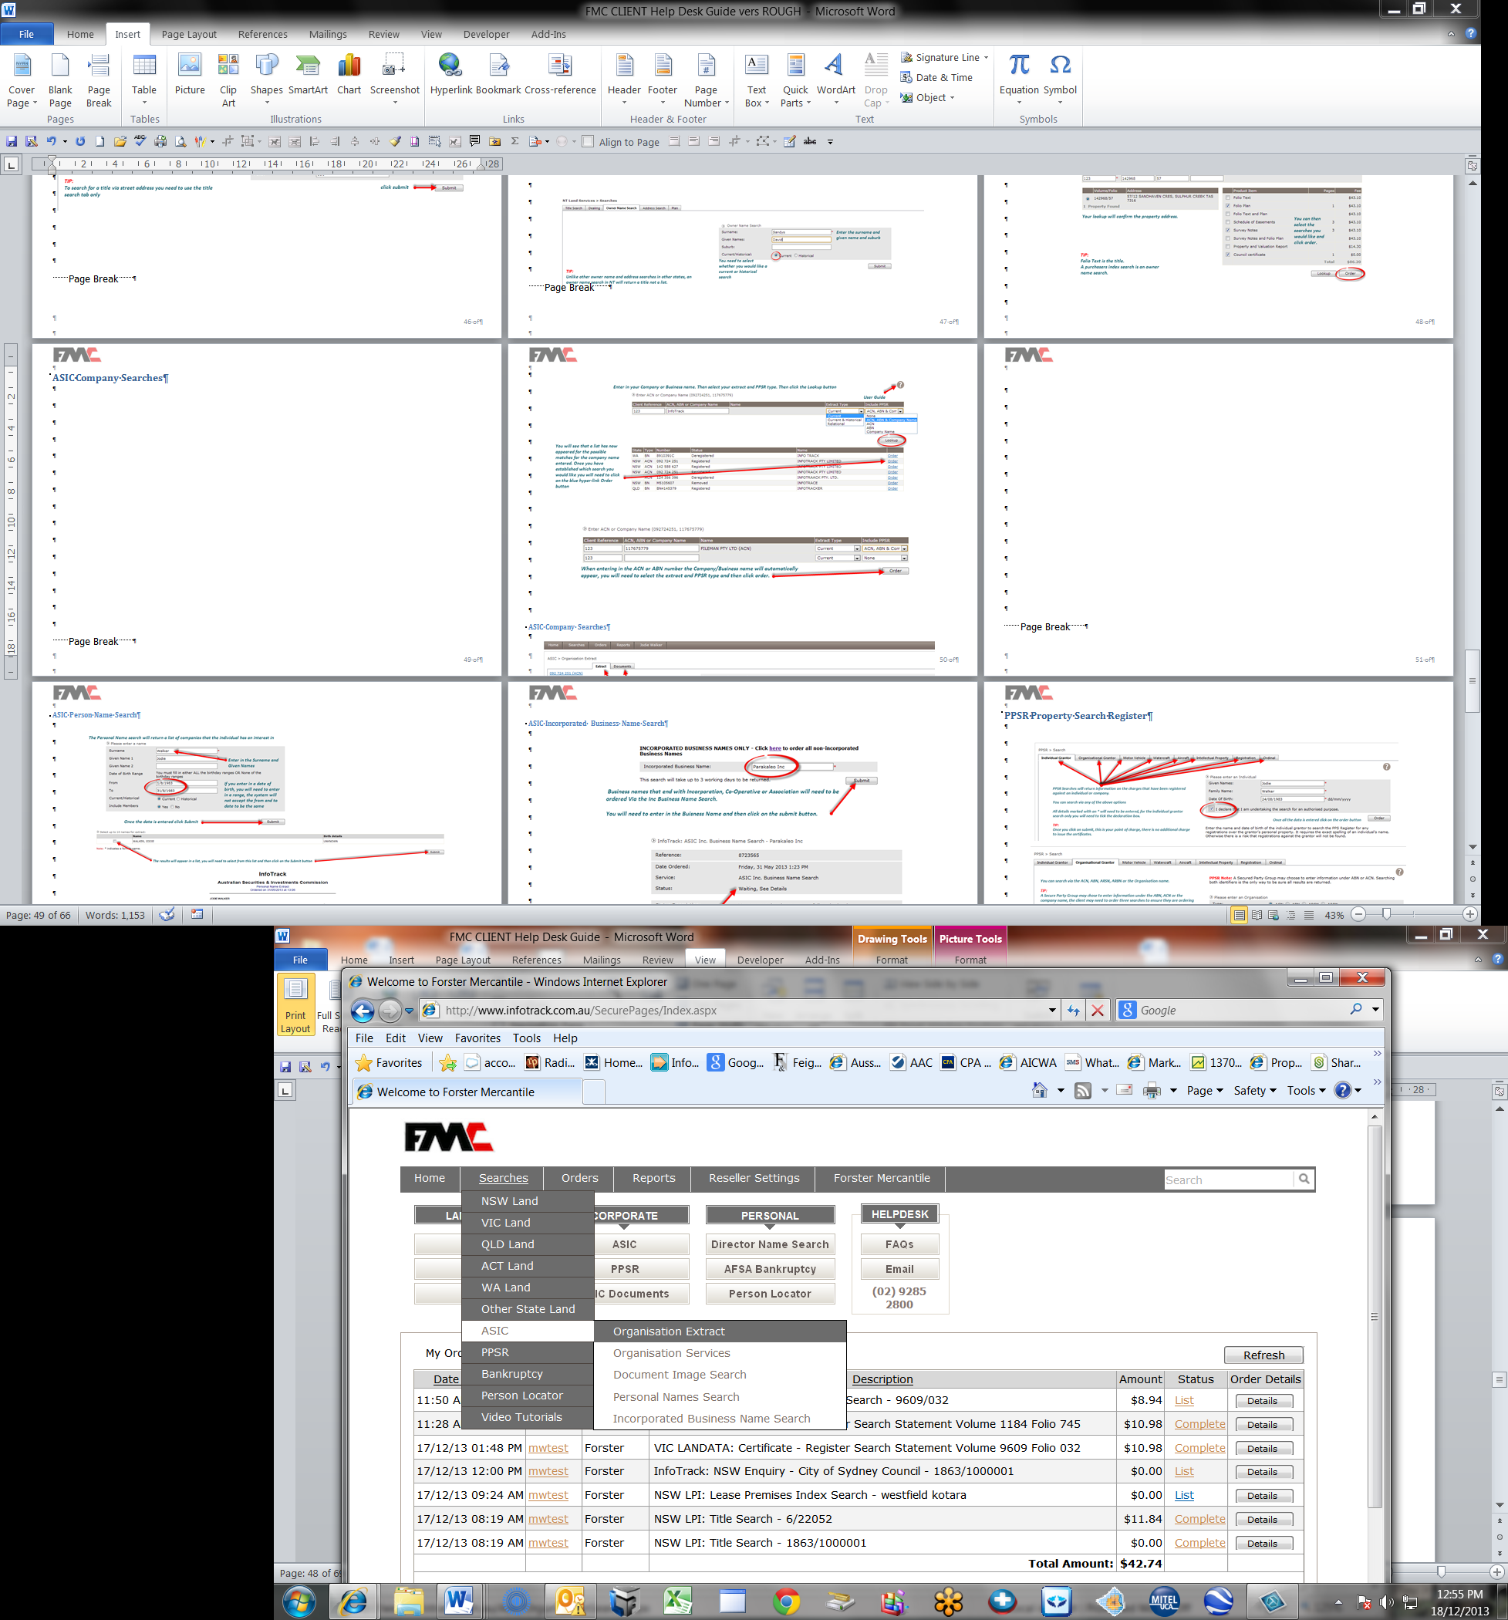
OR
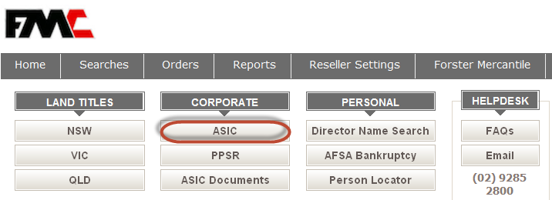

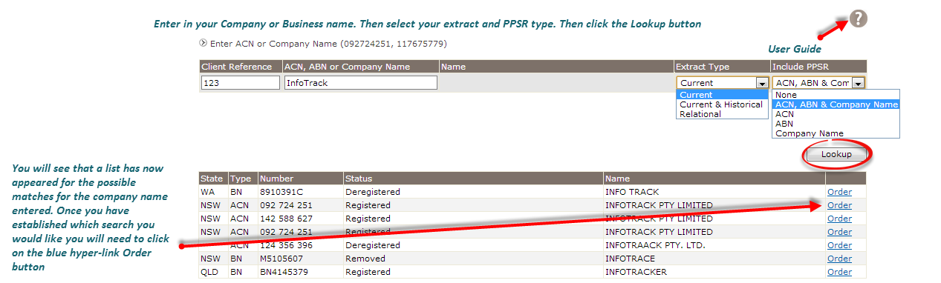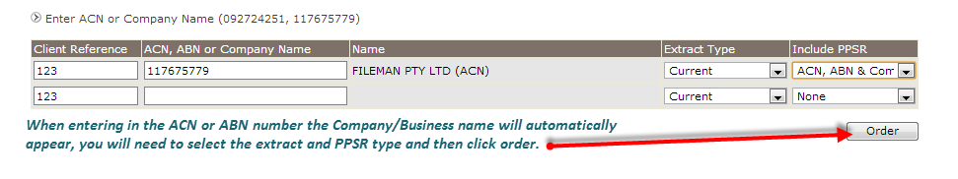

Company Search ResultsASIC
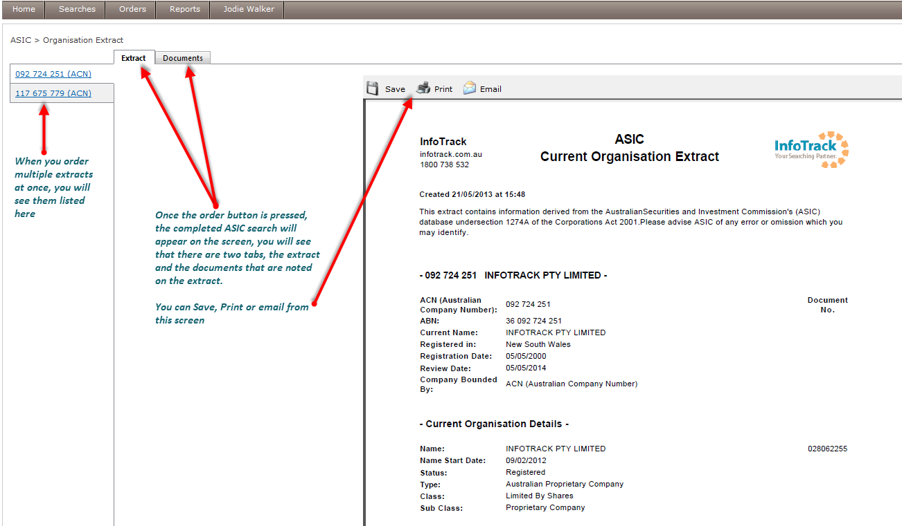

Director Name Search ASIC

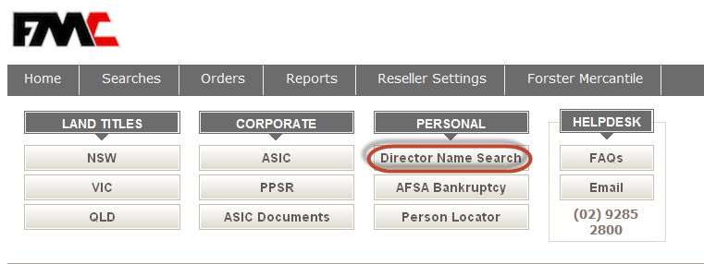

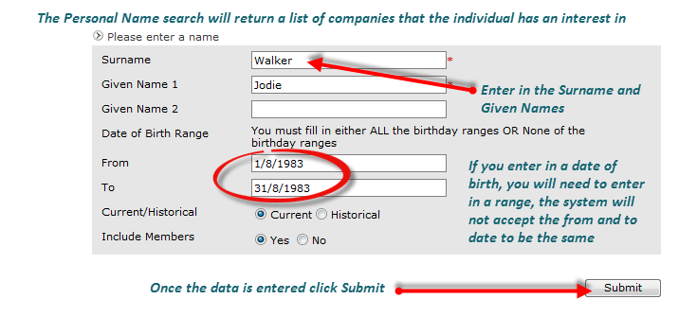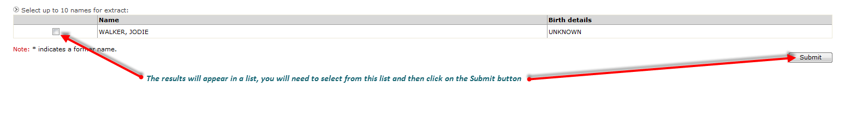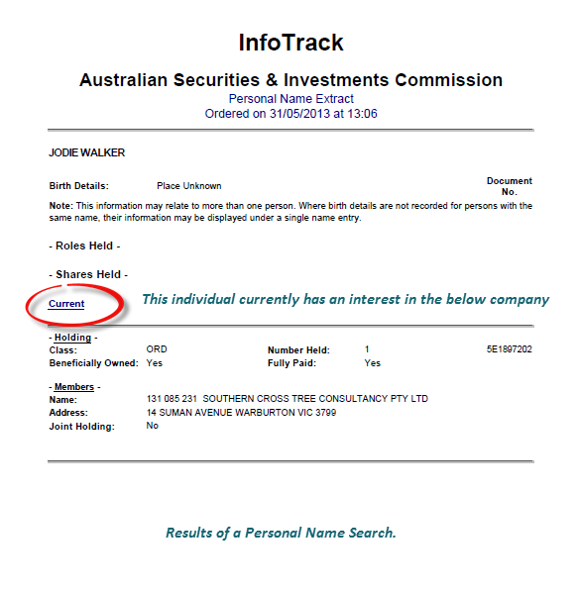

Incorporated Business Name Search
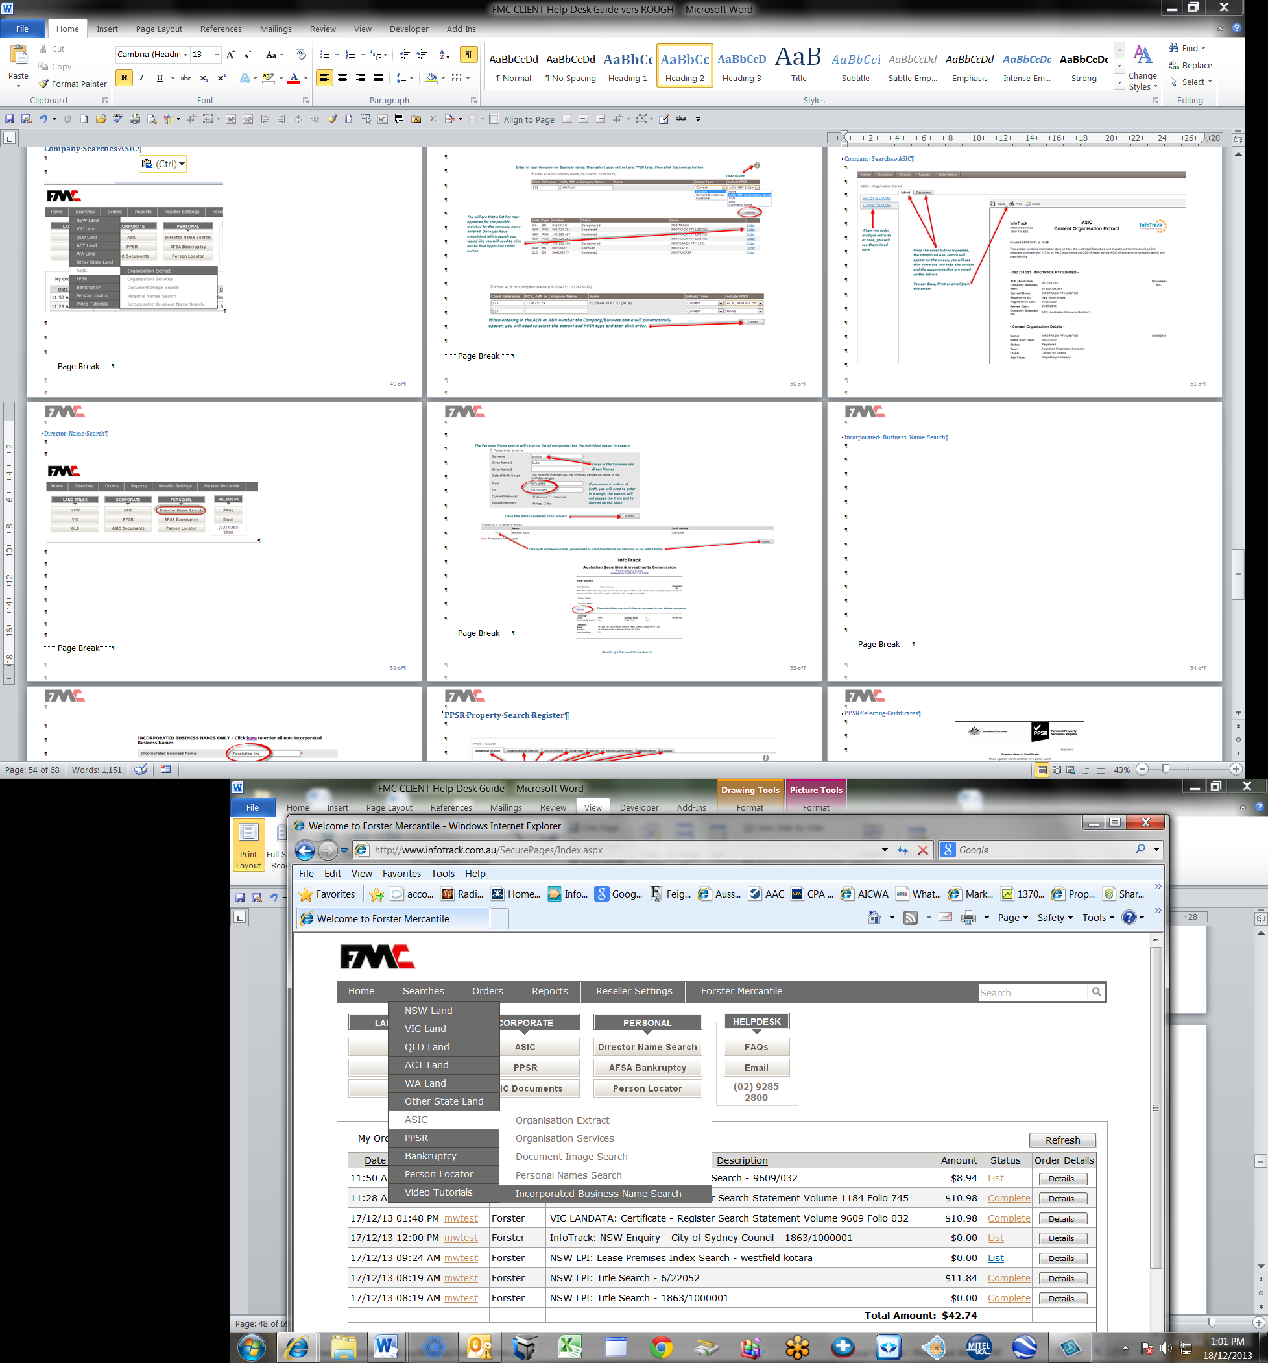

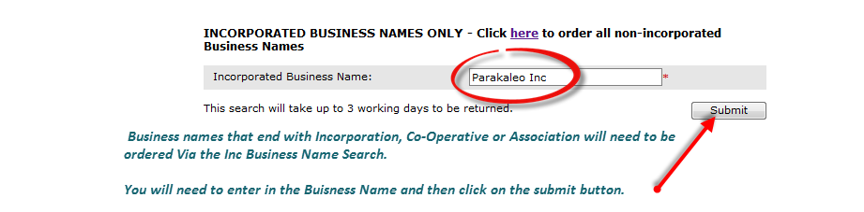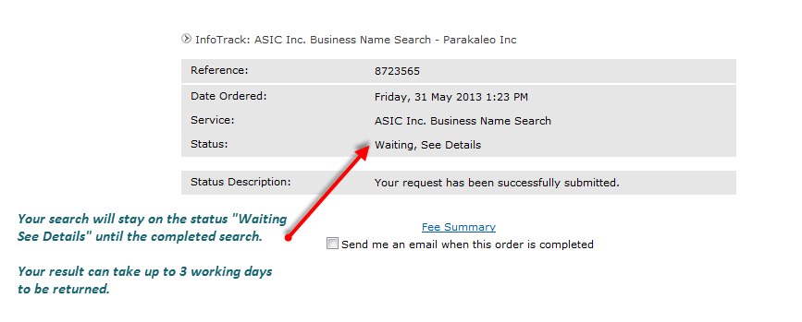

Documents ASIC
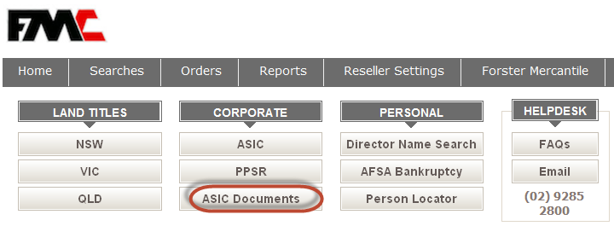

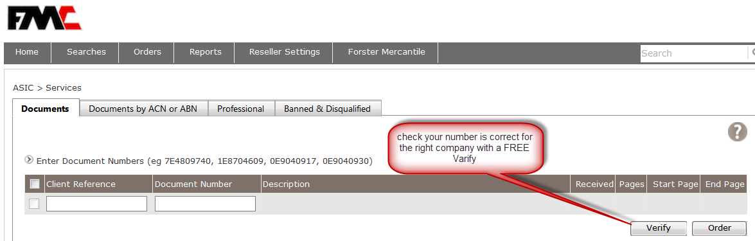

Documents Professionals, Banned & Disqualified ASIC
Check Personal Name Search Registers contains details of those persons who are banned & disqualified from managing companies
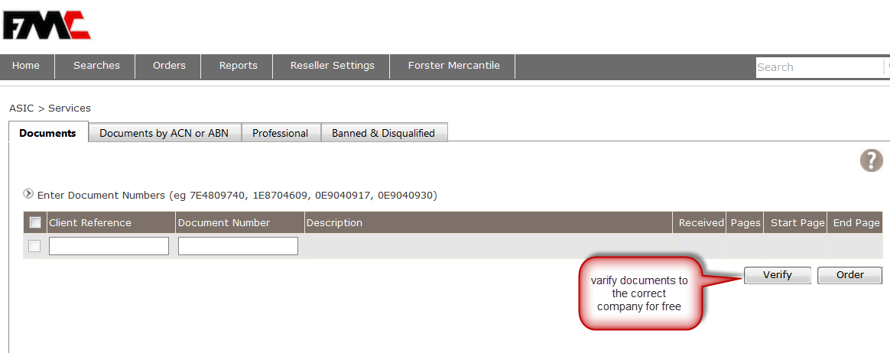

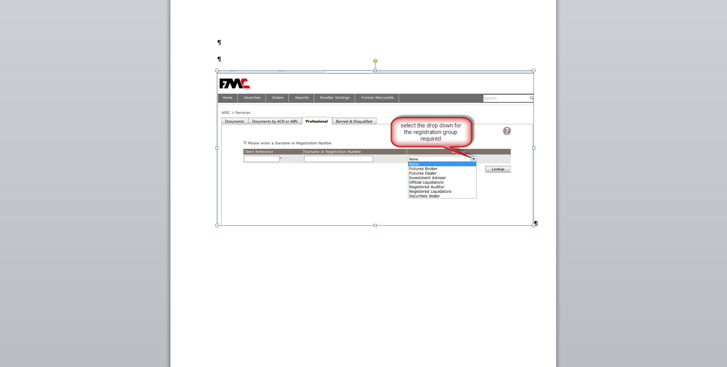

Looking Up RegistrationsPPSR
Find ownership of non-real estate goods & property
Check to see if there is an Organisational Grantor or Individual Grantor Search registered, Check claims of ownership by a finance company search Serial Numbers for Motor Vehicles, Watercraft, Aircraft or Helicopter, plus Intellectual Property including Design Number, Patent Number, Plant Breeder’s right number and Trade Mark number,. Check which registration has priority over another and check expiry dates
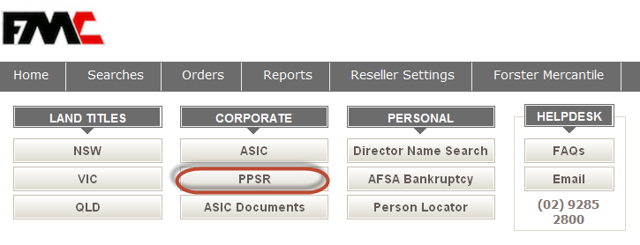
Organisational SearchPPSR
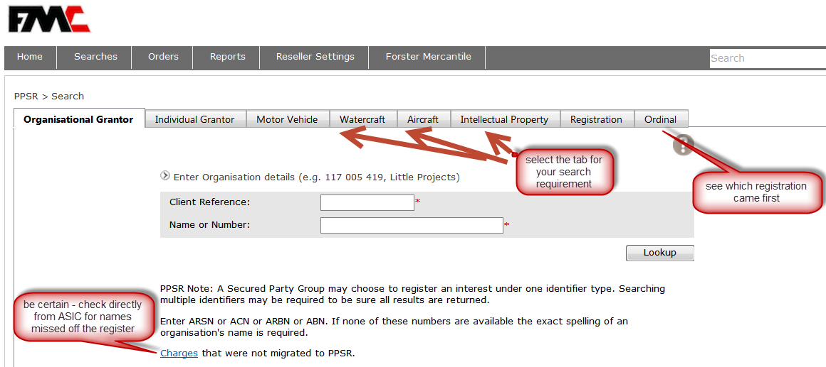

Individual Search PPSR
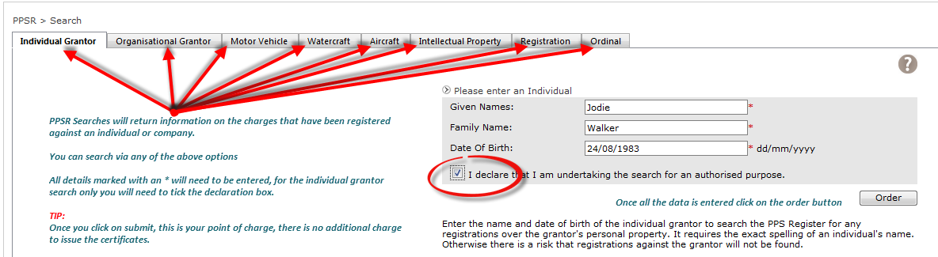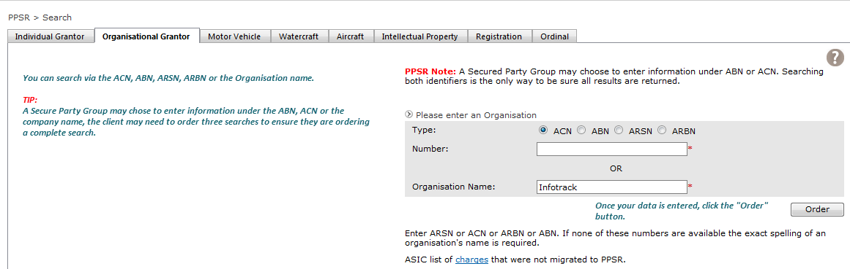

PPSR Selecting Certificates
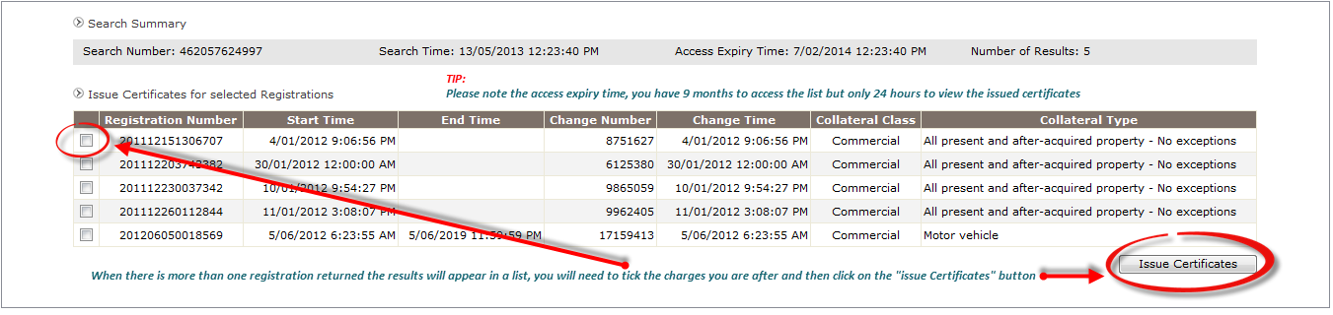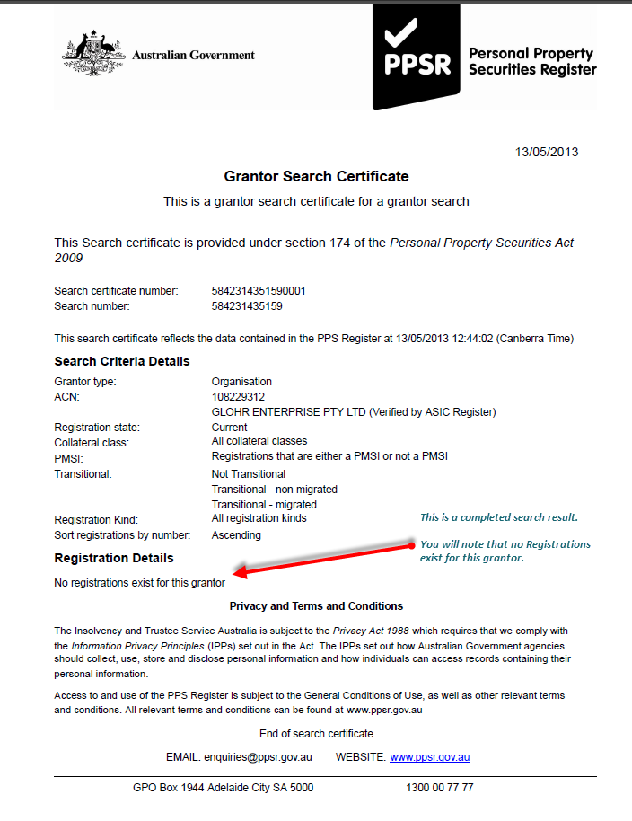

PPSR Tab Selection
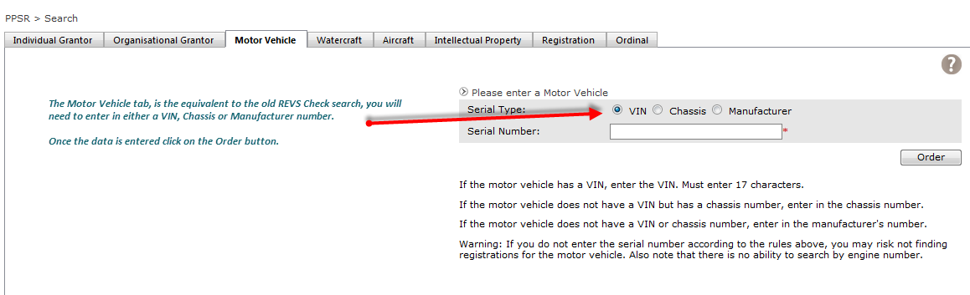

RegisteringPPSR

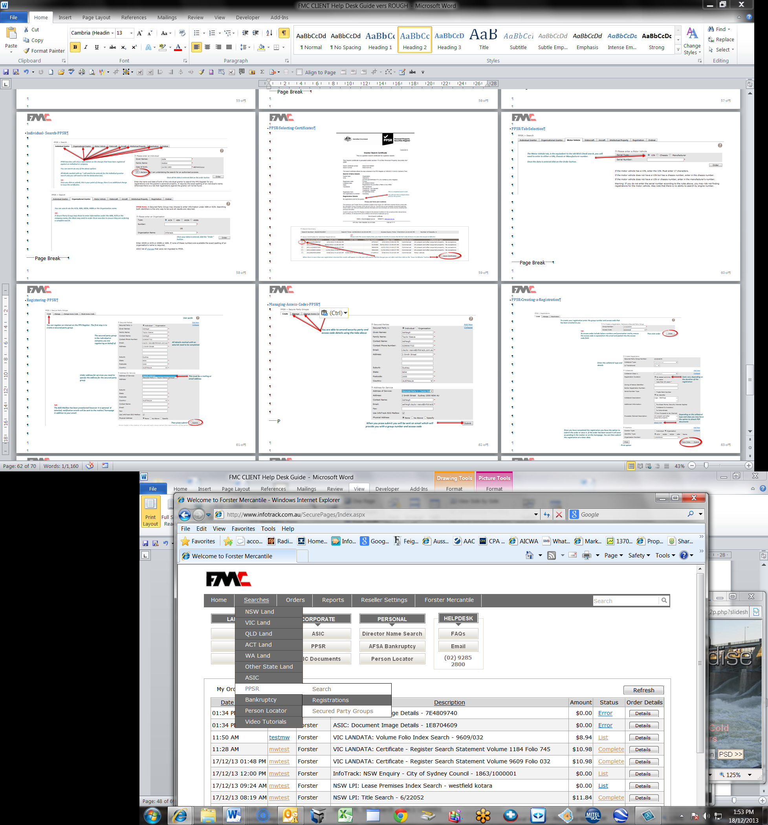

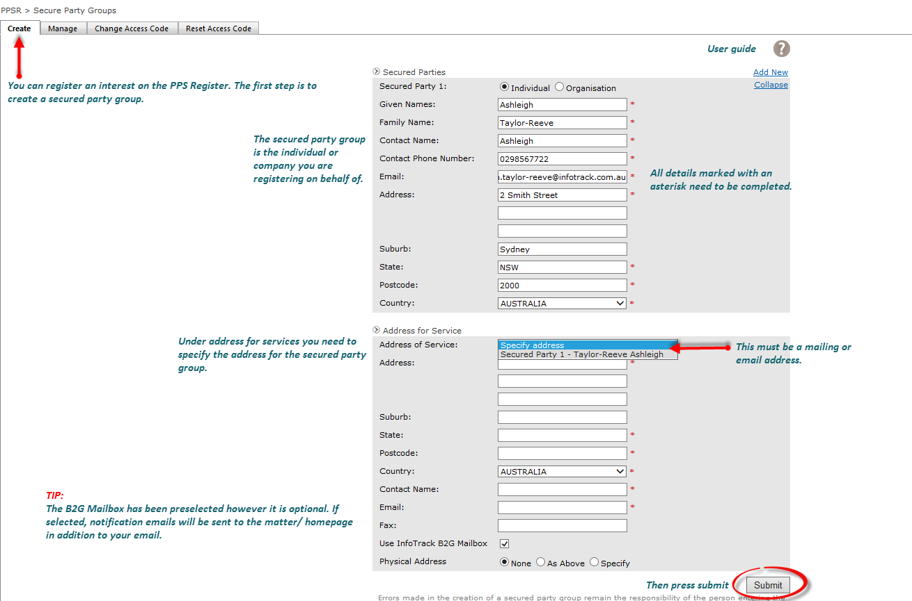

Managing Access CodesPPSR
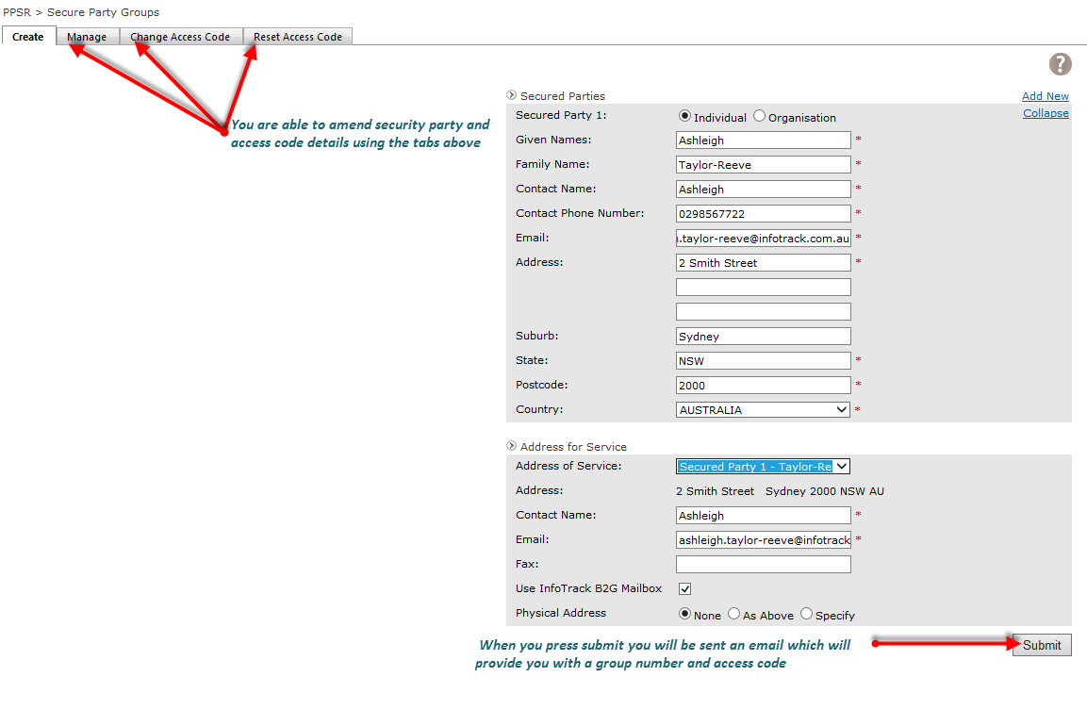

Creating a RegistrationPPSR

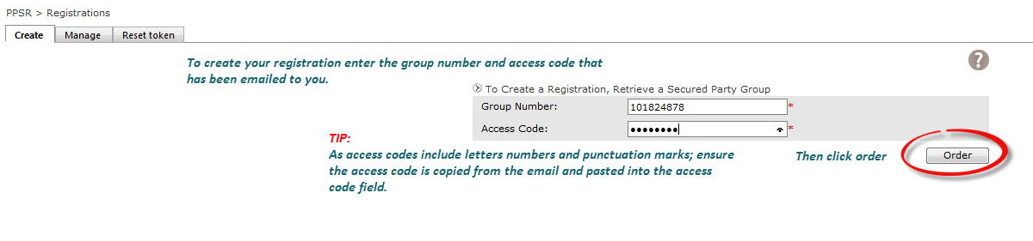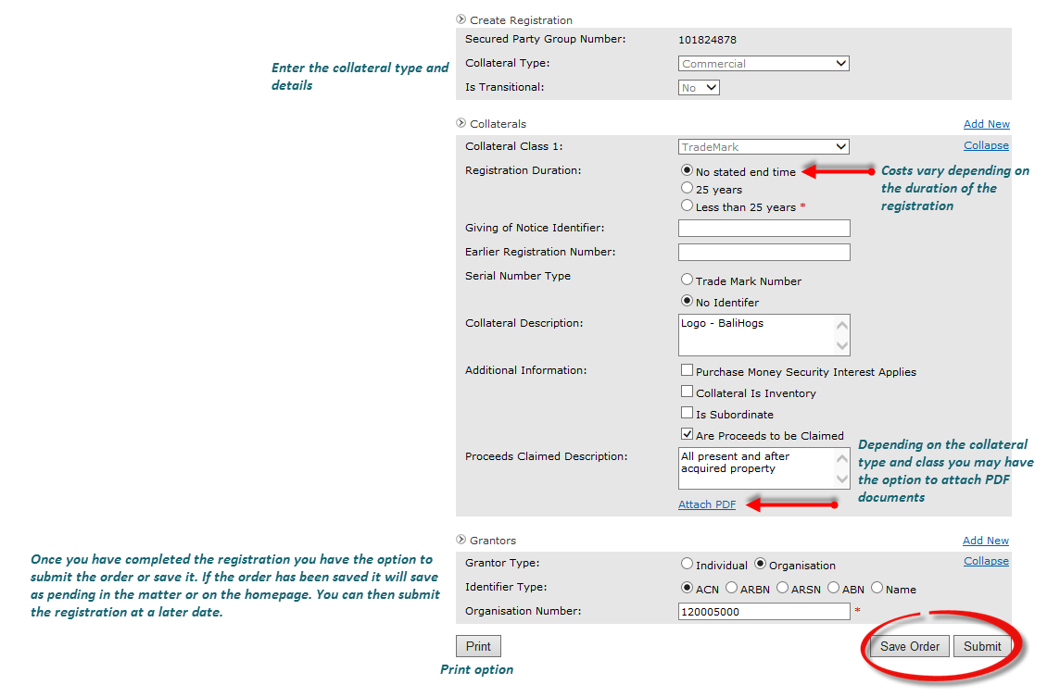

Amending a RegistrationPPSR
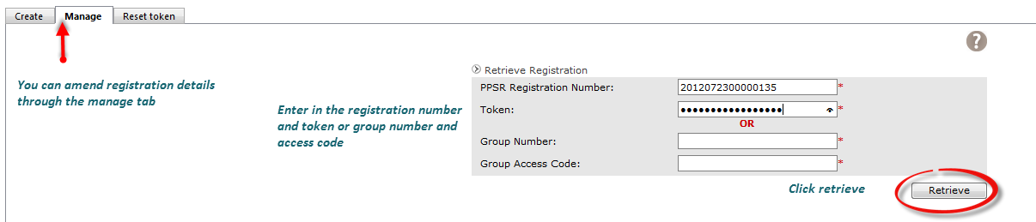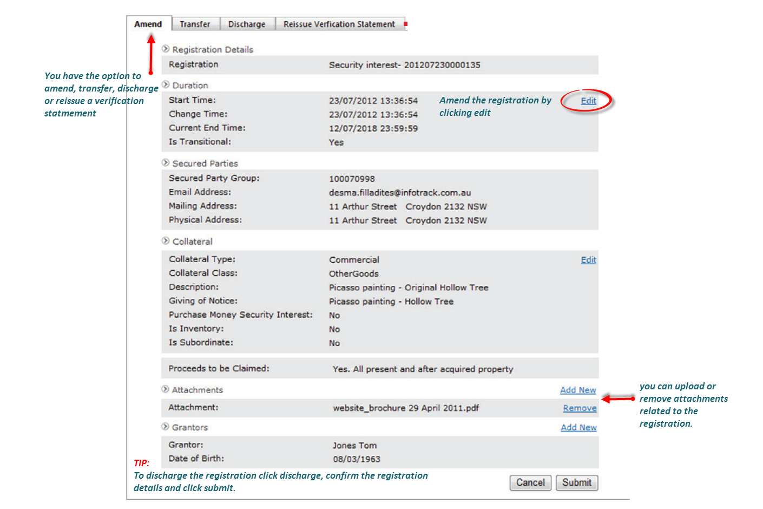

AFSA Bankruptcy Search

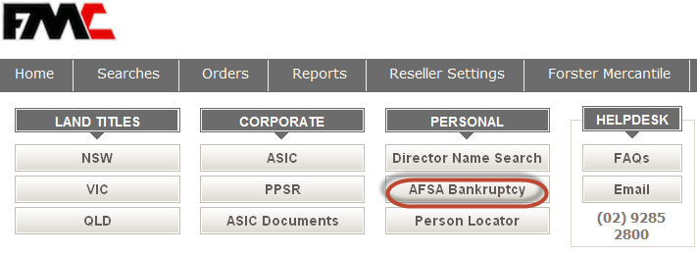
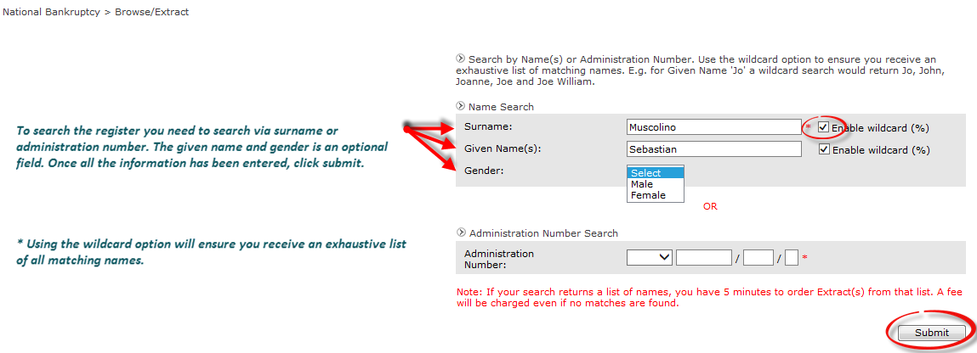

AFSA Ordering Extract
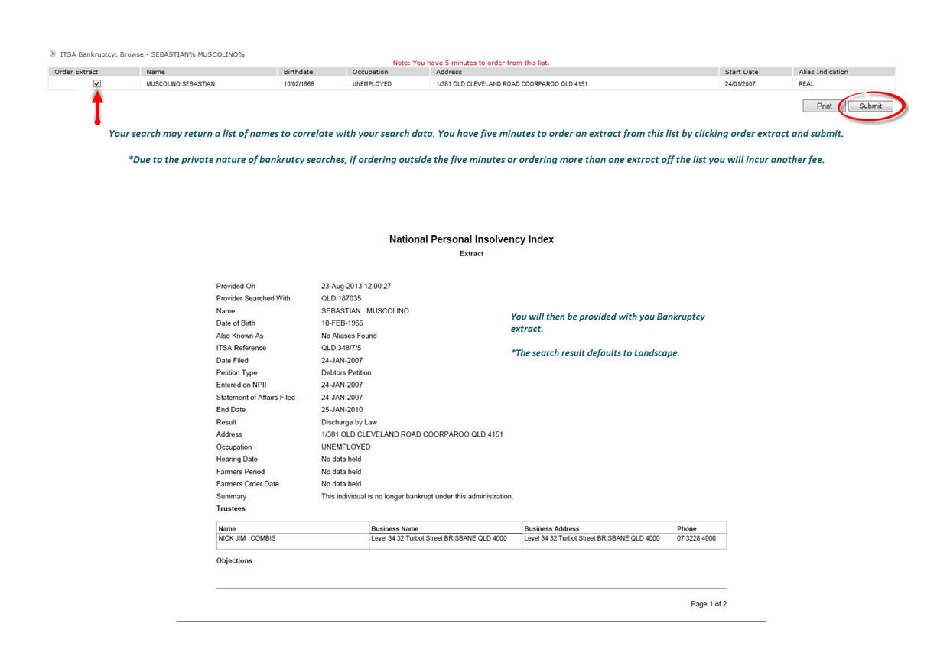

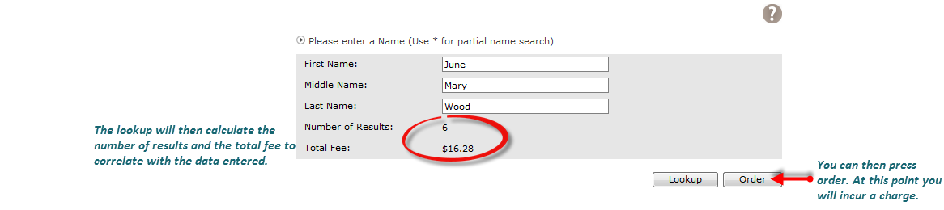

Person Locator Search
Access over 140 million National records in a few seconds. Personal Locator enables you to search for and find individuals and couples, by simply entering their data
Check for any current outstanding Federal & Local Court Judgements

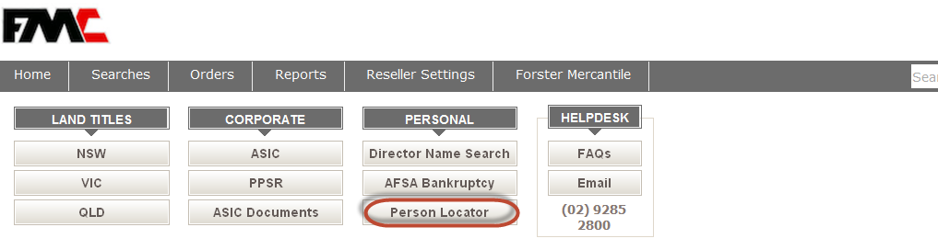
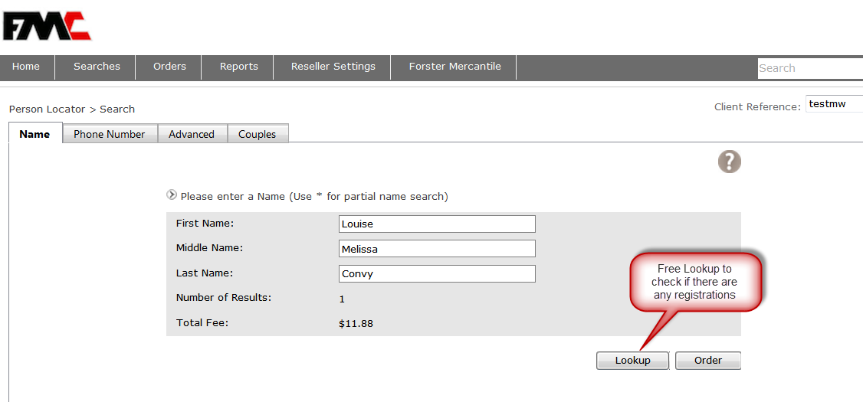

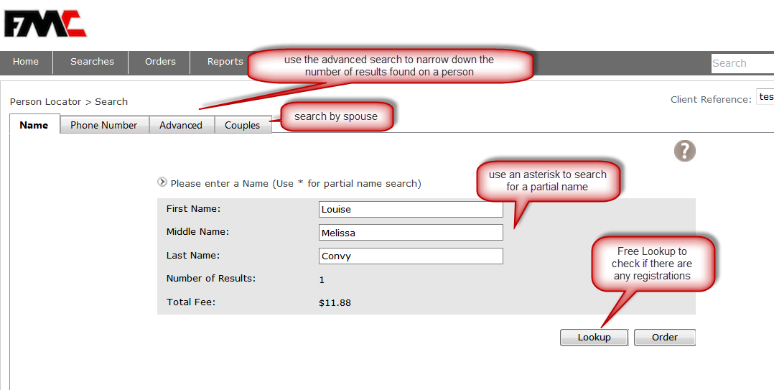

Person Locator Search Printing

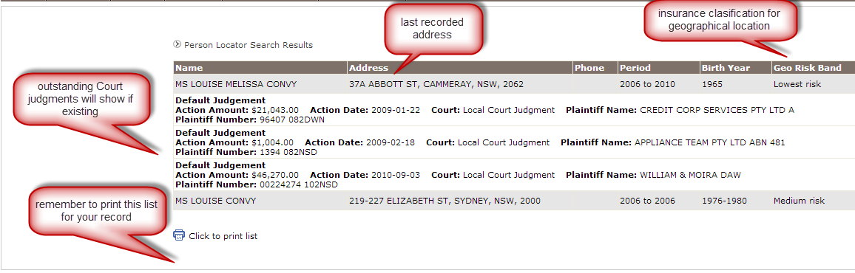

Records Management-Finding past Orders

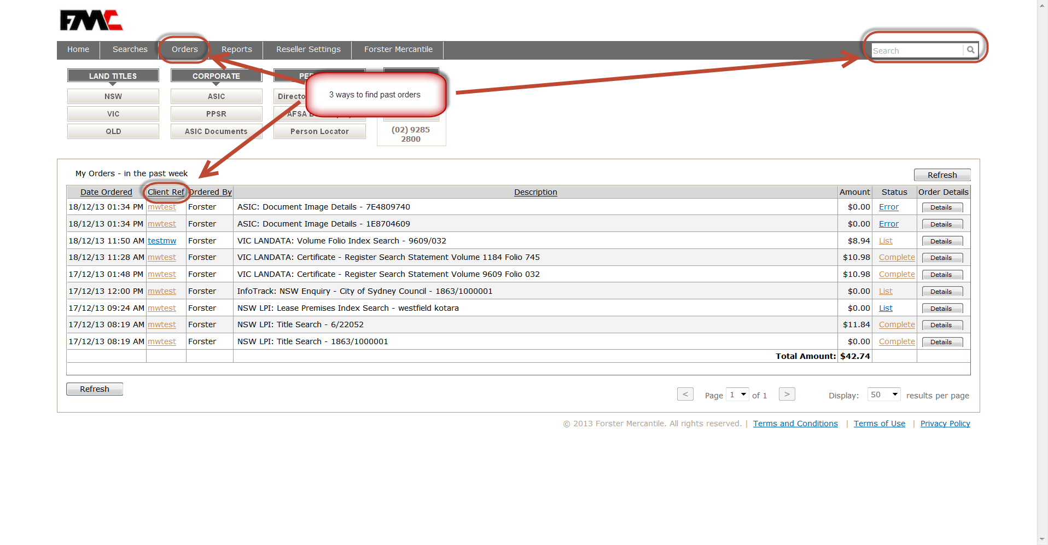

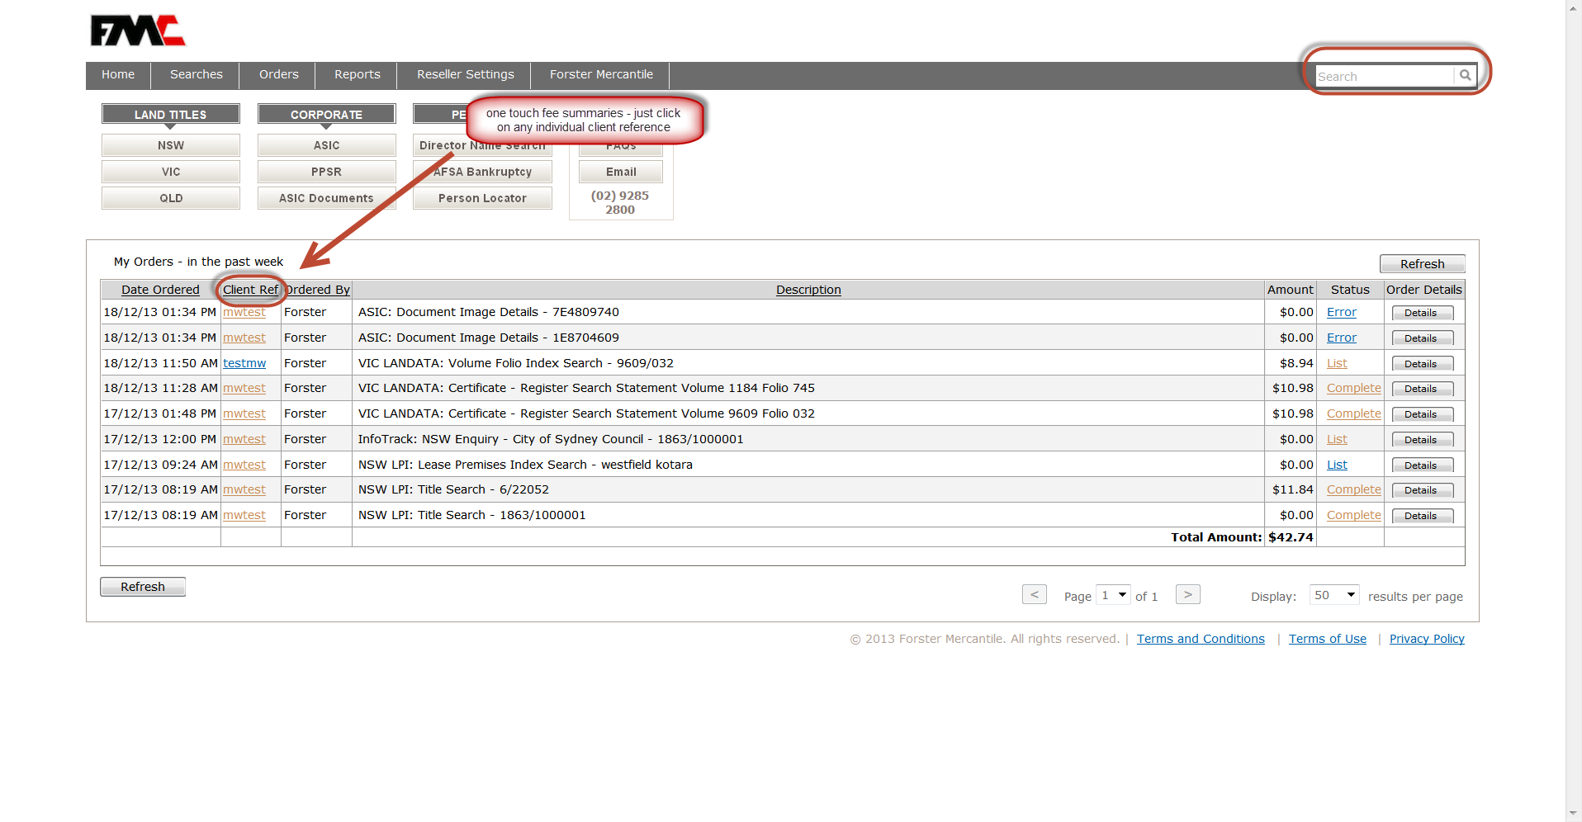
One Touch Fee Summaries

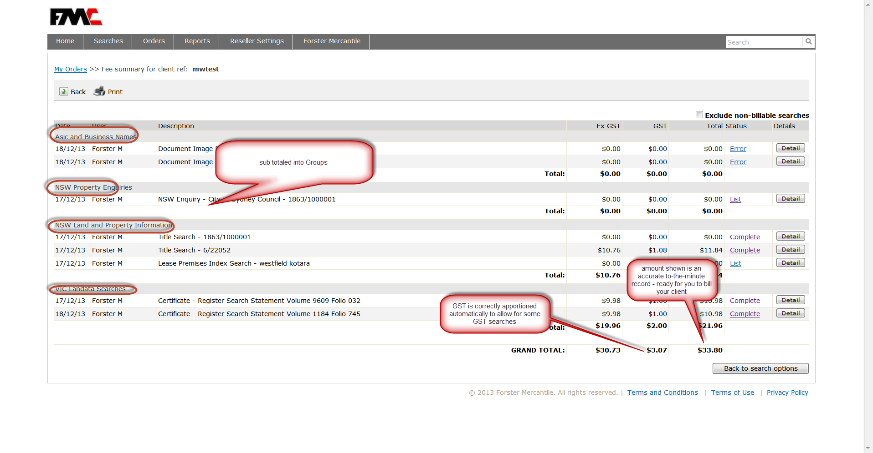

Reports
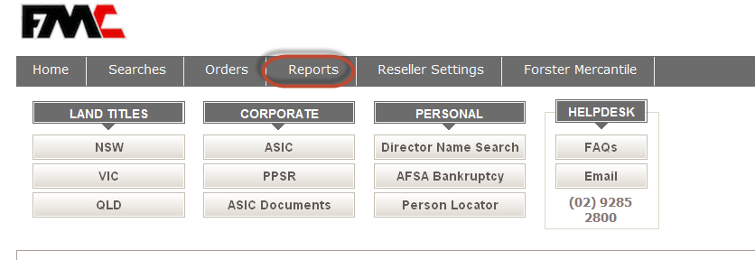
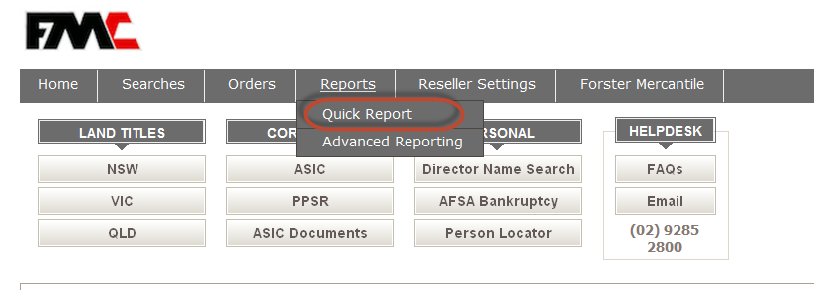
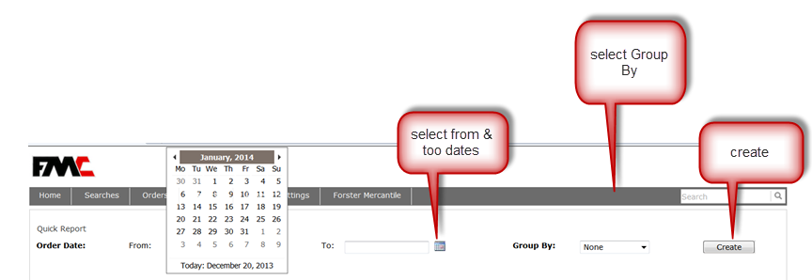

Reports by Date Ordered By Person or All
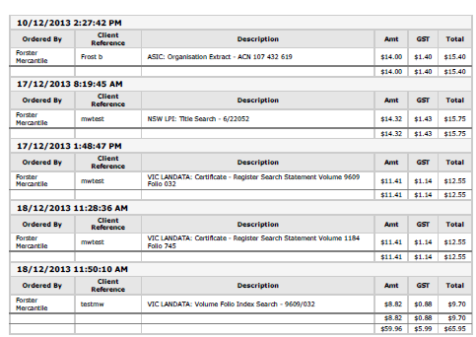
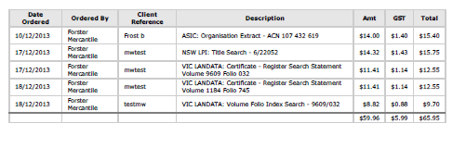

NOTES

